S-100 – Part 8

Imagery and Gridded Data
Summary of Substantive Changes in Edition 5.2.0

Change Summary | Clauses Effected
Part 8 – Imagery and Gridded Data
Removed Table 8-1 and replaced with text referencing ISO 19115-1/2 (Table moved to Appendix 8-D). [All following Table numbers amended accordingly.] Added paragraph clarifying requirement for metadata to conform to S-100 parts 10c and 17. | 8-4.3.1
Amended paragraph to remove language about S100_IF_Collection metadata being optional. Sentence added clarifying that structural, acquisition, and quality metadata are optional except for elements required to describe the coverage format. Amended Figure 8-19 to remove overlapping role names for the association S100_IF_Collection / S100_IF_CollectionMetadata. | 8-5.3
Applied corrections for clarity and grammar. Sentences added to clarify where these abstract classes are realized. | 8-5.3.6, 8-5.3.7, 8-5.3.8
Removed reference to point set data. | 8-5.3.9
Clause heading amended from “Imagery and Gridded Data Metadata” to “Metadata” and clause condensed to avoid duplication of Figure (former Figure 8-28) and accompanying text content in clause 8-5.3. [All following Figure numbers amended accordingly.] Multiple revisions to remove duplicative language, remove digressions and introduce a reference to quality metadata. Sentence added mentioning the new location of suggested metadata supporting scanned paper charts. | 8-9
The former clause 8-13 (Metadata for scanned image) moved to Appendix 8-D. | 8-13 (Edition 5.1.0)
New clause “Typical metadata” (metadata-related content moved from clause 8-4.3.1). | 8-D-1
New clause heading “Derivation of S-100 metadata and ISO metadata” inserted and Table number for the pre-existing table “Relationship between packages of metadata and metadata classes” added. | 8-D-2
New clause “Metadata for scanned image” added (content moved from the former clause 8-13). | 8-D-3

Contents

8-1 Scope 1
8-2 Conformance 1
8-2.1 Conformance of this Profile with other Standards 1
8-2.2 Backward compatibility 1
8-2.3 Conformance to this Profile 2
8-3 References 2
8-3.1 Normative references 2
8-3.2 Informative references 2
8-4 Imagery and Gridded Data Framework 3
8-4.1 Framework structure 3
8-4.2 Abstract level 5
8-4.3 Content model level 5
8-4.3.1 Metadata 7
8-4.3.2 Encoding 7
8-5 Imagery and Gridded Data Spatial Schema 8
8-5.1 Coverages 8
8-5.1.1 General overview of coverages 8
8-5.1.2 Discrete coverages 8
8-5.1.3 Continuous coverages 8
8-5.2 Point sets, grids and TINs 8
8-5.2.1 Point sets 8
8-5.2.2 Grid types 9
8-5.2.3 Rectangular grids and irregularly shaped grids 10
8-5.2.4 Simple and tiled grids 11
8-5.2.5 Regular and variable cell sizes 11
8-5.2.6 Grids in 2 or 3 dimensions 13
8-5.2.7 TIN 15
8-5.2.8 Grid cell structure 15
8-5.3 Dataset structure 16
8-5.3.1 S100_Dataset 17
8-5.3.2 S100_DatasetDiscoveryMetadata 17
8-5.3.3 S100_ExchangeSet 17
8-5.3.4 S100_IF_Collection 18
8-5.3.5 S100_IF_CollectionMetadata 18
8-5.3.6 S100_IF_StructuralMetadata 18
8-5.3.7 S100_IF_AcquisitionMetadata 19
8-5.3.8 S100_IF_QualityMetadata 19
8-5.3.9 S100_IF_Coverage 19
8-5.3.10 S100_IF_Tiling 19
8-5.3.11 S100_IF_IdentificationMetadata 19
8-5.3.12 S100_IF_ContentMetadata 19
8-5.3.13 SC_CRS 19
8-6 Tiling Scheme 19
8-7 Spatial Schema 20
8-7.1 S100_IF_PointSet spatial model 20
8-7.2 CV_GeometryValuePair and subclasses 21
8-7.3 S100_IF_PointCoverage spatial model 22
8-7.4 S100_IF_TINCoverage spatial model 23
8-7.5 S100_IF_GridCoverage spatial model 24
8-7.6 Rectified or georeferenceable grids 27
8-7.7 Common enumerations 28
8-7.7.1 CV_CommonPointRule 28
8-7.7.2 CV_SequenceType 29
8-7.7.3 S100_CV_InterpolationMethod 30
8-8 Data Spatial Referencing 30
8-8.1 Gridded data spatial referencing 30
8-8.1.1 Georectified 31
8-8.1.2 Ungeorectified 31
8-8.1.3 Georeferenced 31
8-8.1.4 Georeferenceable 32
8-8.2 Point set data and TIN triangle vertex spatial referencing 32
8-9 Metadata 32
8-10 Quality 33
8-11 Imagery and Gridded Data Portrayal 33
8-12 Imagery and Gridded Data Encoding 33
8-13 Feature Oriented Image 33
Appendix 8-A Abstract Test Suite (normative) 35
Appendix 8-B Terminology (informative) 37
Appendix 8-C Quality Model for Imagery and Gridded Data (informative) 39
Appendix 8-D Metadata (informative) 41
Appendix 8-E Feature Oriented Images 47

Scope
S-100 has the capability to support imagery, gridded and several other types of coverage data as an integral component. Imagery and gridded data are common forms of geographic data and there exist many external standards designed to handle such data. An image is a particular type of gridded data structure that can be visualized. Since almost all sets of gridded data can be portrayed to form an image, the term image is very broad. S-100 must not preclude compatibility with external sources of data.
Certain kinds of hydrographic information such as soundings, current information and water level information are by their nature a set of data points distributed over an area. Other kinds of information relevant to water-borne transportation, such as meteorological information, are also data points distributed over an area. Images are also of great importance for hydrographic data. This includes images from sensors such as aerial photography or LIDAR, photographs that can be associated with vector based feature oriented data and products based on scanned paper charts, commonly known as “Raster Charts”. All of these types of data are covered by this Part of S-100.
A set of data comprised of a set of attribute values distributed over an area is called a coverage. There are many different types of coverages, for example grid structures of different types such as elevation models using a regular grid spacing; irregular grids with variable size cells; Triangulated Irregular Networks (TINs), etc.
This Part of S-100 aligns with the international standards for imagery and coverage data in order to support multiple sources of data. It uses a set of common information structures, based on the ISO TC/211 19100 suite of standards, that allows application systems to display or otherwise combine imagery, gridded and coverage data with boundary defined (vector based) data and other types of data.
This Part of S-100 defines content models and conceptual structures for grid based coverages (simple grids and selected kinds of complex grids) as well as point set coverages and TINs, for coverage data in hydrographic applications, including imagery as a type of gridded data. It describes the organization, type of grid or other coverage structure and associated metadata and spatial referencing for georeferenced data. The manner by which encoding and portrayal makes use of the content models are described in other Parts of S-100.

Conformance

Conformance of this Profile with other Standards
This Part defines a profile of ISO 19123:2005 concepts and types that constitutes the conceptual basis for the relevant S-100 encoding format (S-100 Part 10c — HDF5 Data Model and File Format), and for S-100-based Product Specifications describing data products based on gridded information and other coverage-type products.
This Part utilises the approach taken by ISO/TS 19129 and concepts defined in that specification to define specific conceptual structures combining ISO 19123 concepts in order to provide a simplified common basis for the S-100 encoding format for coverage-based hydrographic data, which is described in Part 10c.

Backward compatibility
Part 8 in this edition of S-100 is a correction, restructuring and rationalization of Part 8 in S-100 5.0.0, intended to correct internal discrepancies and update the conceptual framework to make it fully compatible with the encoding format for coverage information specified in S-100 Edition 5.0.0 Part 10c (HDF5 encoding). It simplifies Part 8 in previous editions of S-100 by removing superfluous concepts but does not entail changes to Product Specification data formats that conform to Part 10c of S-100 Edition 5.0.0.

Conformance to this Profile
The Abstract Test Suite presented in Appendix 8-A indicates how a coverage based product complies with the content models established in this document.
Any product addressing imagery, gridded or coverage data, claiming conformance with S-100 shall pass the requirements described in the abstract test suite, presented in Appendix 8-A.

References

Normative references
The following referenced documents are required for the application of this document. For dated references, only the cited edition applies. For undated references, the latest edition of the referenced document (including any amendments) applies.
IHO S-97, IHO Guidelines for Creating S-100 Product Specifications
ISO/TS 19103:2005, Geographic information — Conceptual schema language
ISO 19107:2003, Geographic information — Spatial schema
ISO 19111:2007, Geographic information — Spatial referencing by coordinates
ISO 19115-1:2018, Geographic information – Metadata – Part 1 – Fundamentals (as updated by Amendment 1, 2018)
ISO 19115-2:2009, Geographic information — Metadata - Part 2 Extensions for imagery and gridded data
ISO 19123:2005, Geographic information — Schema for coverage geometry and functions
ISO/TS 19129:2009, Geographic information — Imagery, Gridded and Coverage Data Framework
ISO 19157, Geographic information — Data quality

Informative references
The following references have been superseded by later editions or are otherwise useful though not normative.
ANSI T1.523-2001, Telecommunications Glossary 2000, American National Standard T1.523-2001. (Defines the term “data compaction” which is used in this Part and defined in S-100 Annex A — Terms and Definitions.)
IHO S-52, Specifications for Chart Content and Display Aspects of ECDIS, Edition 6.1.(1), October 2014 (with clarifications up to June 2015)
IHO S-61, Product Specification for Raster Navigational Charts (RNC)
IHO S-98, Data Product Interoperability in S-100 Navigation Systems, Edition 1.0.0, May 2022
ISO 19108, Geographic information — Temporal schema
ISO 19113, Geographic information — Quality principles
ISO 19114:2003, Geographic information — Quality evaluation procedures. (Superseded by ISO 19157.)
ISO 19117, Geographic information — Portrayal
ISO 19118, Geographic information — Encoding
ISO 19130:2010, Geographic information — Imagery sensor models for geopositioning
ISO/IEC 12087-5:1998, Computer graphics and image processing -- Image Processing and Interchange (IPI) - Functional Specification - Basic Image Interchange Format (BIIF)
ISO/IEC 15444-1:2004, Information Technology -- JPEG 2000 image coding system

Imagery and Gridded Data Framework

Framework structure
The framework for Imagery, Gridded and Coverage data used in this Part of S-100 is derived from ISO 19129 Imagery, Gridded and Coverage data Framework. Only a subset of the framework defined in the ISO standard is required in S-100. The framework as described in ISO can support both georeferenced and georeferenceable data. This component of S100 is limited to georeferenced data although it can easily be extended in the future to address georeferenceable data such as sensor data.
The framework identifies how the various elements of a coverage dataset fit together. The framework provides a common structure that establishes an underlying compatibility between different sets of coverage data. The common framework established in ISO 19129 fosters a convergence at the "Content Model" level between different sets of imagery and gridded data expressed using different standards and also between the information holdings expressed using these standards. An underlying compatibility at the content model level for a broad range of imagery and gridded data allows for backward compatibility with existing standards. The content model describes information independent of the way in which it is stored, communicated or portrayed. This permits multiple encodings for the same content.
Gridded data, including imagery data, is fundamentally simple. It consists of a set of attribute values organized in a grid together with metadata to describe the meaning of the attribute values and spatial referencing information to position the data. Other coverage data is also simple. It also defines a set of points or triangles that drive a coverage function together with metadata. The metadata may contain identification information, quality information, such as the sensor from which the data was collected. The spatial referencing information contains information about how the set of attribute values is referenced to the earth. The spatial referencing information itself is expressed as metadata.
Auxiliary information, also expressed as metadata, may assist in portrayal or encoding, however the basic content may be portrayed in different ways or carried using different encoding mechanisms, so such auxiliary information is not a part of an imagery and gridded data content model. Figure 8-1 illustrates the simple structure of gridded data.

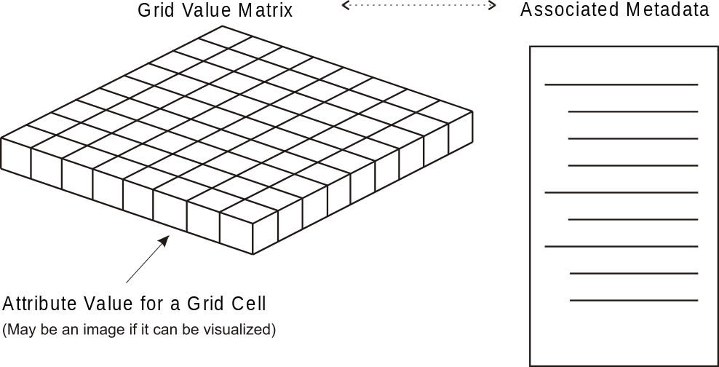
Figure 8-1 – Simple structure of gridded data
(Showing the Relationship of Metadata to
a set of Gridded Data Represented in a Grid Value Matrix)

The ISO 19129 framework standard allows Imagery, Gridded and Coverage data to be described at several levels. These are an abstract level as addressed in ISO 19123 Geographic information - Schema for coverage geometry and functions, a content model level and an encoding level. The encoding level is independent from the content level. Multiple different encodings may carry the same content.
Most of the existing standards relating to imagery and gridded data describe data content in terms of its representation in an exchange format. The format defines data fields and describes the contents and meaning of these data fields. This implicitly defines the information content that can be carried by the exchange format. Defining the content in terms of its encoding binds the content to that single encoding format and makes data conversion very difficult.
The ISO 19100 suite of standards defines geographic information content in terms of an object oriented data model expressed in the Unified Modeling Language (UML), which allows the content to be encoded using different exchange formats or stored in a database irrespective of the exchange encoding. The following figure, corresponding to ISO 19129, presents the overall relationship between the elements of the framework.
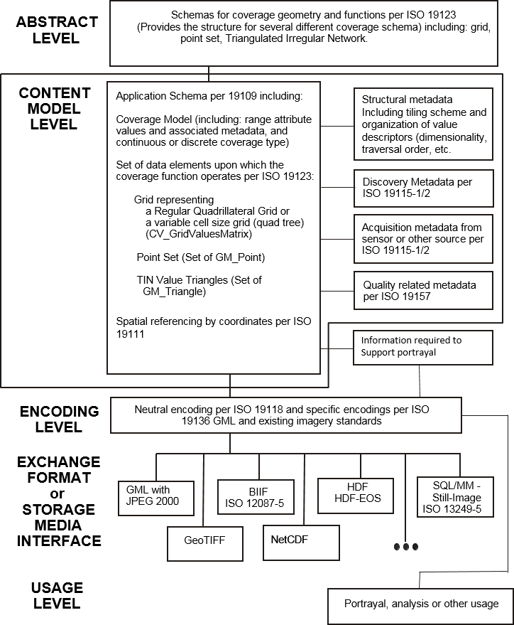
Figure 8-2 – Overall relationship between the elements of the framework
S-100 requires certain discovery metadata elements to be provided in an Exchange Catalogue (S-100 Part 17), and permits the use of additional files conforming to the ISO 19115-3 format to encode additional metadata, including structural, acquisition, and quality metadata.

Abstract level
The abstract level provides a generic structure for all types of coverage geometries including gridded data geometries and point set and TIN geometries. This abstract structure is defined in ISO 19123 – Geographic information – Schema for coverage geometry and functions. S-100 takes from ISO 19123 various types of grid structures including a rectangular grid, an irregularly shaped grid, a grid with variable cell sizes and a multi-dimensional grid. A tiled grid is actually a set of grids. S-100 also includes a point coverage and a TIN coverage derived from ISO 19123.

Content model level
The content model level describes the information content of a set of geographic information consisting of: the Spatial Schema, feature identification and associated metadata, where other aspects such as quality, geo-referencing, etc, is represented in the metadata. The content model does not include portrayal or encoding or the organization of the data to accommodate various storage or exchange media. Exchange metadata that describes the information about a data exchange is not part of the information defined by the content model.
The content model level consists of a set of predefined content structures, which serve as the core for various Application Schemas to be developed for imagery, coverage and gridded data. This Part defines a small set of grid structures, with associated traversal orders. These provide a set of spatial organizations for gridded data. A point set structure and a TIN structure are also defined.
The feature model defined in ISO 19109 “Geographic information - Rules for Application Schema” as profiled in S-100 Part 3 applies to imagery and gridded data. The Application Schema defines one or more geographic feature types whose attributes are the elements of the respective value record. For example, a bathymetry grid may define a geographic feature type with attributes for depth and uncertainty. The geometric component for each feature type may be modelled by one of the spatial types described in this Part.
Although the conventional approach is to consider an image as a unique entity on its own, and to not consider a feature structure, it is proper to consider imagery, gridded and coverage data as feature oriented data. In the simplest form, an image or any set of gridded data can be considered as a single feature. For example, an entire satellite image could be considered as a single feature – the image. However, it is also possible to do feature extraction on an image, where sets of pixels are the geometric representation of a feature. Certain selected pixels could correspond to a bridge, and other pixels correspond to a rock. An Application Schema can contain a feature model, where the geometric component of the feature model consists of sets of geometric points corresponding to the picture elements (pixels) in a grid structure of an image. However, if a feature structure is associated with an image it is necessary to provide a method of linking feature IDs to individual pixels in the image. This can be done by carrying additional attributes in the grid value matrix, or by a pointer structure. For example, an image may be represented as a simple grid consisting of a set or rows and columns providing organization to a set of pixels. Each pixel contains attributional data such as the colour and light intensity seen at that point. Each pixel may also contain an additional attribute that indicates the feature ID associated with the pixel, so that the pixels corresponding to the image of a bridge are marked as the feature bridge, and those corresponding to a rock are marked as rock. Other more efficient structures may be defined to identify sets of pixels as corresponding to a given feature. This capability is particularly useful for adding intelligence to raster scanned image paper chart products, and for fusing S-100 vector data products with imagery and gridded data products.
Figure 8-3 below depicts the overall structure for imagery, gridded, or coverage data. The Content Model includes the spatial structure and the metadata. The encoding structure is separate but related. Systemic compression which allows for data compaction is part of the content model whereas stochastic compression which allows for data compression is not. An example of systemic compression is the removal of information that is known by the application to be not necessary. This would include areas over which there is no data (sub-tiling), and the removal of lower order bits of numeric data for lower precision numbers. A tiled grid exhibits systemic compression when tiles are only defined for areas where there is data. Systemic compression also exists in a variable size pixel structure where adjacent pixels of the same attribute value can be aggregated into a single larger pixel. Stochastic (statistical) compression removes redundant information that occurs randomly. For example, repeated bit patterns that can be compressed by an algorithm. The ZIP algorithm often used to compress files is an example of stochastic compression. Systemic compression relates to a particular type of image, whereas stochastic compression relates to a particular instance of an image. Both types of compression may be applied, but the stochastic compression is part of the encoding structure, whereas the systemic compression is part of the content model.
Image, Gridded and
Coverage Data
Associated Metadata
Context Metadata
(per ISO 19115-1 & ISO19115-2)
Content Metadata (
per ISO 19115-1 & ISO 19115-2)
Portrayal Metadata
(
per ISO 19115-1 & ISO 19117)
Representational Structure
Data Compression
Metadata Encoding
(
per ISO 19115-3, ISO 12087-5 or other)
Value set encoding
(
per ISO 15444, ISO 12087-5 or other)
Data Structure
Spatial Referencing
(
per ISO 19111 & ISO 19107)
Value set
Grid Value Matrix
(
per ISO 19123)
Discrete Point Set
(
per ISO 19123)
Value Triangle
(
per ISO 19123)
Data Compaction
Figure 8-3 – Image and gridded data structure
Figure 8-4 below presents the elements contained in a general content model for imagery gridded and coverage data. This is a subset of Figure 8-3 above, with the representational structure not shown, since it is not part of the content model. The mechanism for systemic compression is not directly shown because it relates to the structure of the Grid Value Matrix.
Image, Gridded and
Coverage Data
Associated Metadata
Context Metadata

about the environment or
context of data (per ISO 19115-1 & ISO 19115-2)
Content Metadata

about the semantics or
meaning of data (per ISO 19115-1 & ISO 19115-2)
Data Structure
Spatial Referencing
(
per ISO 19111 & ISO 19107)
Value set
Grid Value Matrix
(
per ISO 19123)
Discrete Point Set
(
per ISO 19123)
Value Triangle
(
per ISO 19123)
Data Compaction

Figure 8-4 – General imagery and gridded data content description

Metadata
Typical metadata elements for geographic datasets are defined in ISO 19115-1/2, with additional elements relating to data quality in ISO 19157. Appendix 8-D lists a selection of these elements typically used for imagery, gridded, and coverage data.
— Metadata Elements

Product Specifications are not required to define metadata corresponding to the elements listed in ISO 19115-1/2 or Appendix 8-D, but must include the mandatory metadata elements described in S-100, and may include the optional metadata elements described in S-100 as well as requiring additional product-specific metadata.
Depending on the requirements of the data product, Product Specifications may provide metadata using any combination of the following methods:
- Externally to the dataset, in the Exchange Catalogue or additional metadata files.
- Within dataset files using one or both of the following methods:
  - As attributes of the dataset, of a feature type, or individual feature instances.
  - By defining additional feature types which are also encoded in datasets as coverage features.
If the metadata are encoded as additional feature types, the Application Schema should define feature or information types defining the attributes and, for feature types, a spatial representation which must be one of the spatial types defined in this Part.
In determining whether metadata is encoded in the Exchange Catalogue or within dataset files, Product Specifications must conform to S-100 Parts 10c and 17. Unnecessary duplication of metadata in both external and internal forms is possible but discouraged.

Encoding
The content model defines the structure to which an encoding rule may be applied. There are a large number of different encodings used for imagery, gridded and coverage data that provide encoding services for this class of information. Many of these encodings are well used standardized exchange formats. S-100 provides a common content model structure that can be encoded or stored using different encoding formats (for example Figure 8-2, GeoTIF).
For the coverage encoding format, S-100 uses the Hierarchical Data Format (HDF version 5), which is object oriented and suitable for all types of coverage data, including point sets and TIN triangles. The S-100-mandated profile of HDF5 is described in S-100 Part 10c.

Imagery and Gridded Data Spatial Schema

Coverages

General overview of coverages
A coverage associates positions within a bounded space to attribute values. A coverage is a subtype of feature; that is, it associates positions within a bounded space to the attribute values of the feature. A continuous coverage function associates a value to every position within the spatial temporal domain of the function. A discrete coverage function is only valid at specific positions within the domain. Geometric objects within the spatiotemporal domain drive the coverage function. A coverage function effectively acts as an interpolation function for the geometric objects within the spatiotemporal domain, which establishes a value within the range of the function for every position within the domain.
The geometric objects within the spatiotemporal domain are described in terms of direct positions. The geometric objects may exhaustively partition the spatiotemporal domain, and thereby form a tessellation such as a grid or a TIN. Point sets and other sets of non-continuous geometric objects do not form tessellations.
ISO 19107 defines a number of geometric objects (subtypes of the UML class GM_Object) to be used for the description of features. Some of these geometric objects can be used to define spatiotemporal domains for coverages. ISO 19123 defines additional subtypes of GM_Object that are specialised for the description of spatiotemporal domains. In addition, ISO 19108 defines TM_GeometricPrimitives that may also be used to define spatiotemporal domains of coverages.
The range of a coverage is a set of feature attribute values. The value set is represented as a collection of records with a common Schema. For example, a value set might consist of temperature and depth measured at a given time over a bounded area of ocean. A coverage function may be used to evaluate a depth and temperature anywhere within the bounded area.
The concept of coverages is described in this document to relate coverage functions to the set of geometric objects and the direct positions that drive the coverage functions. It is through the concept of coverages that one may relate the concept of features to a grid, a set of TIN triangles or a point set. This description has been adapted from ISO 19123. S-100 only addresses grids, TINs and point sets.

Discrete coverages
A discrete coverage has a spatiotemporal domain that consists of a finite collection of geometric objects and the direct positions contained in those geometric objects. A discrete coverage maps each geometric object to a single record of feature attribute values. A discrete coverage is thus a discrete or step function as opposed to a continuous coverage. For example assigning a feature code to each cell in a grid cell tessellation is a discrete coverage. Each grid cell is either associated or not associated with a particular feature. Point set coverages in hydrodynamic data, such as observations from distributed sensors, are also frequently discrete coverages in that the data values at any single point in the point set apply only in the vicinity of the point.

Continuous coverages
A continuous coverage has a spatiotemporal domain that consists of a set of direct positions in a coordinate space. A continuous coverage maps direct positions to value records. In principle, a continuous coverage could consist of no more than a spatially bounded, but transfinite set of direct positions, and a mathematical function that relates direct position to feature attribute value.

Point sets, grids and TINs
S-100 addresses only imagery and gridded data associated with grids, TINs and point sets. These constructs establish the basic geometry elements used in this component of S-100.

Point sets
A point set is a set of GM_Point objects in a bounded area. These point objects might each be associated with one or more features. They may also be used to form a coverage and serve to drive a coverage function. Hydrographic soundings may be considered as a point set. For each point set value it is necessary to know the position of the point as well as any associated attribute value and associated feature reference. Attributes may be assigned to an entire point set as an aggregate as well as to individual points. This is common practice for hydrographic soundings where metadata may be associated with a sounding object that consists of a point set of individual soundings. Several point sets may be aggregated into one coverage. A simple point set with associated metadata is illustrated in Figure 8-5.

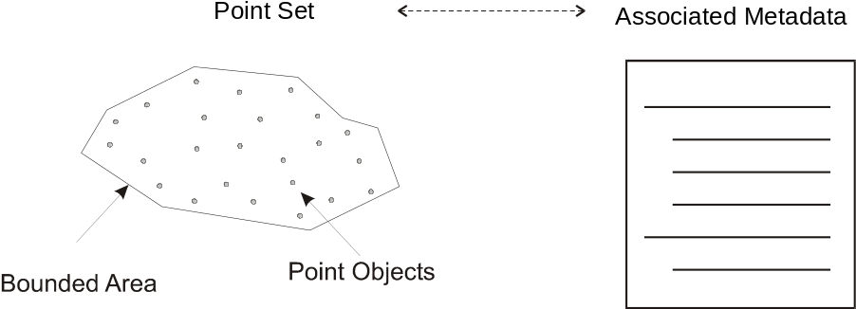
Figure 8-5 – Point Set with associated metadata
A Point Set is a set of 1, 2, 3 or n dimensional points in space. A Point Set Coverage is a coverage function associated with point value pairs in 2 dimensions. That is, a coverage function is driven by a set of points (with X, Y position) together with a record of one or more values at that position.

Grid types
A grid is a regular tessellation of a bounded space where two or more sets of curves in which the members of each set intersect the members of the other sets in a systematic way. The curves are called grid lines; the points at which they intersect are grid points, and the interstices between the grid lines are grid cells. A grid covers the entire bounded space. Grids form the basic geometry for a gridded data coverage. There are several different regular tessellations of a space that are all subtypes of the general concept of grid. Common to all grids is an implicit sequence or traversal order. There also exist a number of possible traversal orders for grids, some more useful than others in different situations. The location of a grid cell is defined implicitly by the regular grid organization and the traversal order. For example, in a rectangular grid each grid cell can be addressed by the row and column order of the grid. It is therefore not necessary to maintain the direct position of each grid cell. More complex grids require more complex traversal orders, however regularity still permits the position within the grid to be determined from the grid structure and the traversal order. The attribute values for a particular grid form a Grid Value Matrix where the matrix entries correspond to the grid cells.
S-100 addresses only a small subset of the possible grids and traversal orders. It makes use of the CV_DiscreteGridPointCoverage and CV_ContinuousQuadrilateralGridCoverage described in clauses 6 and 8 respectively of ISO 19123. It makes use of:
- Rectangular grids and irregularly shaped grids;
- Simple and tiled grids;
- Grid with a regular cell size and variable cell sizes; and
- Grids in 2 or 3 dimensions.
Traversal orders for grids are defined in Annex D of ISO 19123. The types of most interest to S-100 are: Linear Scan; and Morton Order. Figure 8-6 shows a linear scan traversal order and a Morton traversal order for a grid. The Morton ordering can easily accommodate irregular shaped grids, and variable cell size grids. The Morton Order corresponds to a quad tree in two dimensions but is extendable to higher dimensions.
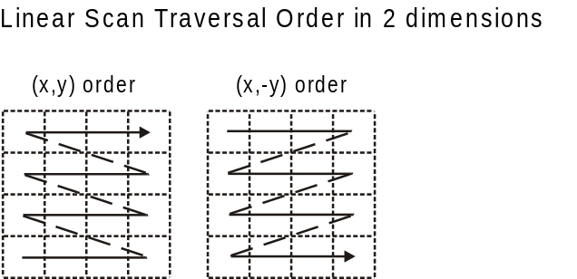

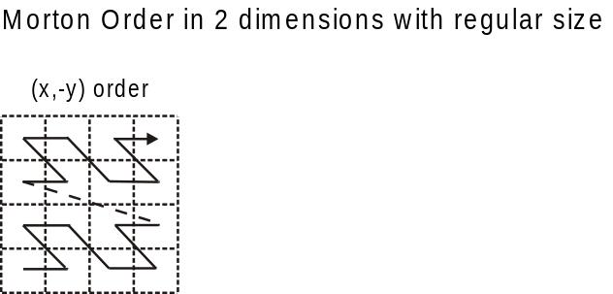

Figure 8-6 – Linear Scan Row Column (X,Y) Traversal Order and Morton (X,Y) Order
These two types of grids and traversal orders have applications for hydrographic data (for example clause 8-5.2.5 – Morton Order).
Other traversal orders defined in the ISO standard 19123 are also permitted in S-100 (see clause 8-7.7.2).

Rectangular grids and irregularly shaped grids
The most common type of grid is a rectangular grid. Most images are defined on such a grid. A rectangular grid is a subtype of quadrilateral grid as defined in ISO 19123. A quadrilateral grid is a grid in which the curves are straight lines, and there is one set of grid lines for each dimension of the grid space. In this case the grid cells are parallelograms or parallelepipeds. A parallelepiped is a three-dimensional figure like a cube, except that its faces are not squares but parallelograms.

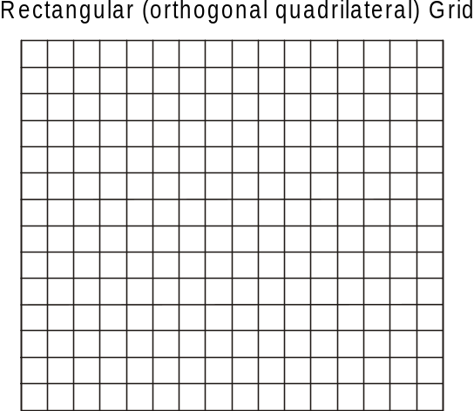
Figure 8-7 – Rectangular grid
A grid may also have a non-rectangular or quadrilateral boundary. Such grids sometimes occur when scanning paper charts that include “insets” or “outsets” that change the boundary of the grid, however the grid can have any shape, as long as it can be traversed in a sequence that gives order to the cells. Figure 8-7 shows a Rectangular Grid. Figure 8-8 shows a quadrilateral grid with an outset, as might occur in a scanning operation.
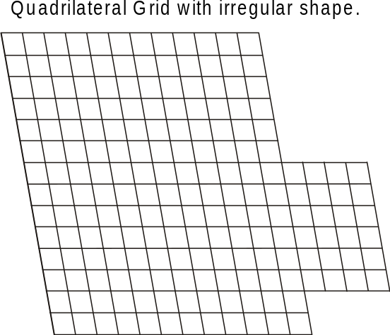
Figure 8-8 – Quadrilateral grid with outset
Very irregular shaped grids may be defined but require a more complex traversal rule than simple linear scanning.

Simple and tiled grids
A tiled grid is a combination of two or more grid tessellations for one set of data. The tiling scheme is essentially a second grid that is superimposed on the first simple grid. Each cell of the tiling scheme grid is itself a grid. A tiling scheme grid may also be used with vector data where each cell defines the boundaries of a particular vector data set. Tiling schemes are of particular value when data is sparse. For example, a raster image map of the United States might be tiled so that it is not necessary to include data over Canada or over the ocean to include Alaska and Hawaii. Figure 8-9 illustrates a tiled grid.
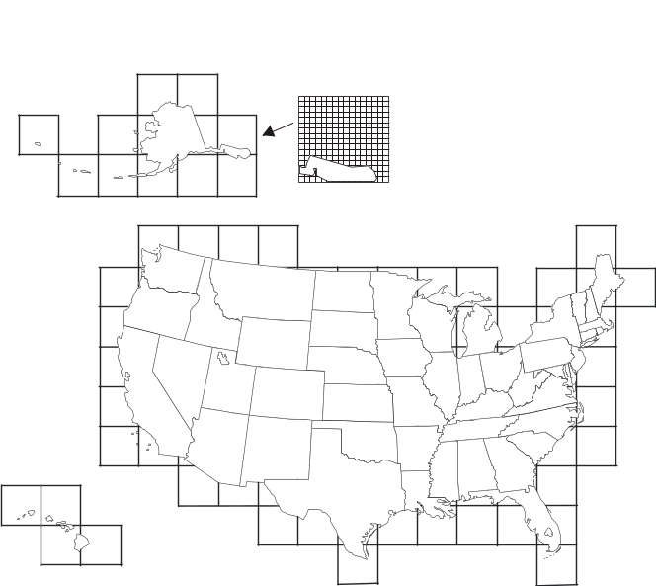
Figure 8-9 – Tiled grid

Regular and variable cell sizes
Traditional grids are fixed ‘resolution’, most commonly composed of perpendicularly crossing lines of equal spacing on each dimension, creating square or rectangular cells. Gridding is a standard way of generalizing point datasets, by imposing a resolution or grid spacing, and calculating individual grid cell values based on a single attribute of the group of points contained within each cell. As well, image data is primarily gridded, based on the resolution of the sensor or uniform arbitrary pixel spacing.
Grids may also be established where the cell size varies within the grid. A common example is the “quad tree” that is commonly used in some Geographic Information Systems. Having a variable size grid cell allows variable resolution throughout the gridded surface, which is exhibited by the unequal spacing of parallel lines that form the grid, localized to given grid cells. This requires the normalization of data on each dimension, and the binary subdivision of each dimension in order to localize any given cell. When applied to point or image data, areas of high variability can be represented by small grid cells. Areas of low variability can be represented by large grid cells. Of course if the cell size varies in a grid, it must do so in a regular way so that the grid tessellation still covers the bounded area, and the traversal method must be able to sequence the cells in an order. In addition it is necessary to include information that describes the size of each cell with the cell.
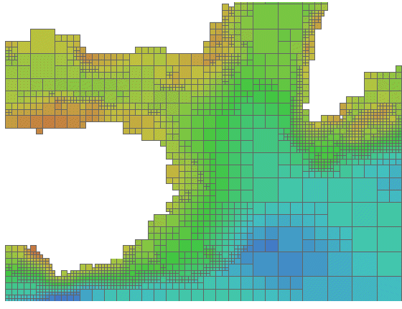
Figure 8-10 – Riemann Hyperspatial grid coverage
(showing depth from hydrographic sonar)
Data in a grid of variable cell size where adjacent like cells have been aggregated into larger cells, maintains the integrity of the original uniformly spaced data, while minimizing storage size. A grid with variable cell size supports null values, so incomplete data – that containing holes – can exist without the need to assign arbitrary values to regions of no data. This allows for a considerable amount of compaction over traditional grids because nothing is stored for cells with no data – they do not exist.
Figure 8-10 above illustrates some variable size cells. If four adjacent cells (in two dimensions) have the same attribute value in the grid value matrix, then they may aggregated into one larger cell. In two dimensions this is known as a "QuadTree". This is of particular use in applications where resolution varies, or where data values tend to cluster.
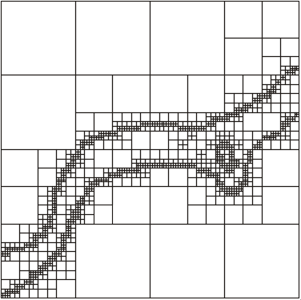
Figure 8-11 – Variable cell sizes
Variable size cells, as illustrated in Figure 8-11, are particularly useful for hydrographic data. Instead of representing bottom cover as soundings (point sets) it can be represented as a set of variable size cells. Each cell can carry several attribute values. Adjacent cells aggregate so the data volume is greatly diminished. Small cells exist where there is a rapid change in attribute value from cell to cell. Shoals, shore line and obstructions result in a number of small cells, where large relatively constant, or flat areas, such as the bottom of a channel result in a number of aggregated cells.
The Morton traversal order can handle variable size cells. The traversal progresses as shown in Figure 8-12. Morton order proceeds from left to right bottom to top cell by cell regardless of cell size. It increments in the X coordinate then the Y. This also extends to multiple dimensions where the increment is in X, then Y then Z then each additional dimension. Figure 8-13 shows Morton ordering in irregular grids and variable size grids. In this example Y, X ordering is used.
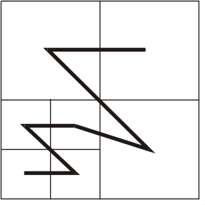
Figure 8-12 – Morton Order (X,Y)
Any space filling curve gives order to a bounded space, but the order imparted by the Morton order preserves nearness. This is a very important property. It means that two points that are close together in the grid are also close together in traversal order of the grid. This property derives from Riemann’s extension of the Pythagorean Theorem into multiple dimensions into what is known as Riemann hyperspace.

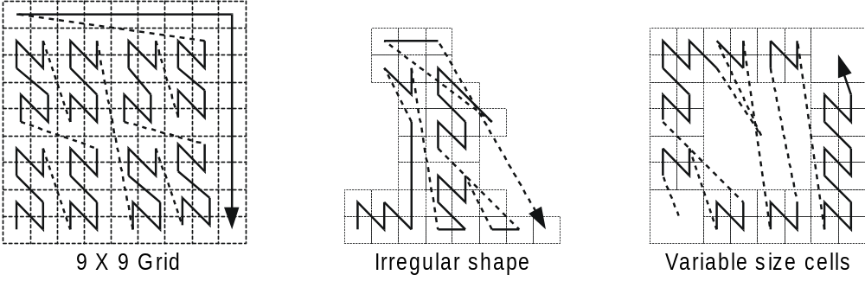
Figure 8-13 – Morton Order in irregular and variable size grids

Grids in 2 or 3 dimensions
Grids may exist in 2 or 3 dimensions. Not all traversal orders will work on higher dimensional grids, but both the linear scan traversal and Morton order traversal can be extended to 3 dimensions. Each dimension in an n-dimensional grid is orthogonal to all other dimensions. Thus, in a 3-dimensional grid or equal cell spacing, there are a set of perpendicularly crossing lines of equal spacing in each dimension, creating cubic cells. These can be thought of as volume elements – voxels.
A quadrilateral grid can easily be extended to 3 dimensions by repeating the grid for each cell “layer” in the third dimension. This is commonly done to support multiple bands of data for the same cell structure, however for true 3 dimensions where the number of cells in the third dimension is large the data volume can become enormous. Figure 8-14 shows a rectangular grid that is extended into the third dimension by repeating the grid for four different bands of data. Figure 8-15 shows a rectangular grid extended to cover a volume.

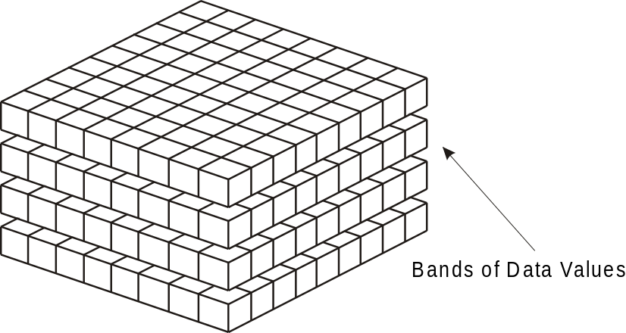
Figure 8-14 – Banding to extend attribute space in a rectangular grid
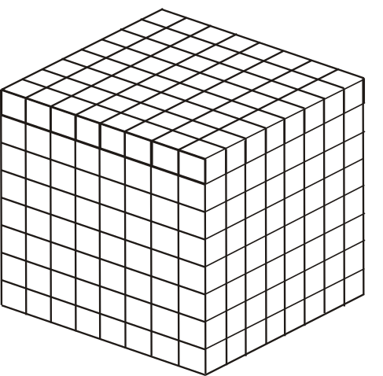
Figure 8-15 – A rectangular grid extended to cover three dimensional volume
Multidimensional Complex Grids exist in n-dimensions and will follow the rules of both these structures, allowing the creation for multidimensional, multi-resolution, aggregate structures. In hydrographic applications one is usually not interested in three dimensional solids but rather the three dimensional representation of the sea bottom and material, including floating material within the water volume related to the sea bottom. Such datasets are sparse, where most of the volume cells (voxels) are empty. If one allows three dimensional cells to aggregate into larger cells when they are the same (within a pre-defined tolerance), then most of the empty cells disappear into a few larger aggregations. The use of variable size cells is useful in handling three and higher dimension data. A variable size cell grid in three dimensions is illustrated in Figure 8-16.
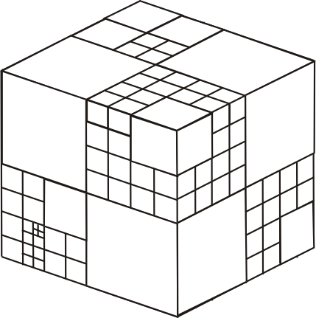
Figure 8-16 – A variable size cell grid in three dimensions

TIN
The Triangular Irregular Network is a method of describing variable density coverage data based on a set of triangles. The TIN structure is very flexible for analysis. Since each triangle is a locally flat surface it is straight forward to calculate the intersection of an arbitrary curve with a surface represented as a TIN. Attributes can be applied to each triangular face, and it is easy, but computationally intensive, to process the faces geometrically, in order to calculate contour lines. In a dynamic navigation system one could easily calculate the potential intersection of a ship's hull with the bottom surface represented as a TIN, and therefore easily determine a dynamic safe contour. The calculation of the intersection of a vector with the surface of a TIN triangle is the simple calculation of the intersection of a line and a plane. An example TIN showing variable size TIN triangles and the TIN vertex points is shown in Figure 8- 17.
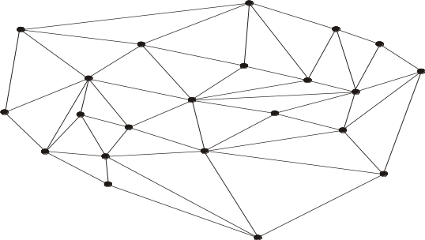
Figure 8-17 – An example coverage composed of TIN triangles
A TIN is composed of a set of triangles. The vertices at the corners of each triangle are shared with the adjacent triangle. These vertices form the control points of the coverage function. There is an inherent overhead involved in a TIN since one must store both the triangles and the vertices. Attribute values are attached to the triangles, whereas the geometry is derived from the position of the vertices. A TIN may be described either by having the triangles reference the shared vertices at their corners, or by having the vertices indicate which triangles they are attached to. Having the triangles reference the vertices is the simpler structure since each triangle has exactly 3 vertices, whereas a vertex may be shared between a variable number of triangles.
A TIN is useful in representing variable density data, since the triangles may be larger where the data is locally smooth, and more dense to represent data with more rapidly changing values. If the points of the TIN are carefully chosen to represent ridges, valleys and other significant features, then the TIN can result in a significant data compaction; however, if a TIN is automatically generated from an arbitrary set of data points the data volume can increase over the original source data, or significant information can be lost, Since a TIN coverage can be of any shape it can be fitted to cover an area of interest.
S-100 uses the CV_TINCoverage class described in ISO 19123. TIN coverages in S-100 are continuous coverages.

Grid cell structure
The feature attribute values associated with a grid point represent characteristics of the real world measured or observed within a small space surrounding a sample point represented by the grid point. The grid lines connecting these points form a set of grid cells.
EXAMPLE: In Figure 8-18 below, the grid points are (a, b, c, d), located at the intersections of the solid lines. The cells (A, B, C, D) bounded by dashed lines represent the sample spaces associated with these grid points. These sample spaces are grid cells in an offset grid (represented by the dashed lines) relative to the data grid (represented by the solid lines). Evaluation at any direct position X within the grid cell G (bounded by the solid lines) will be based on interpolation from a, b, c and d (and possibly involve additional grid points outside the cell).
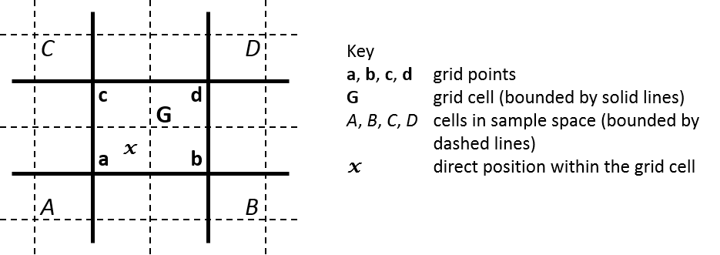
Figure 8-18 – Grid cell structure (after ISO 19123 Figure 15)
S-100 utilizes the same view of grid cell structure as Section 8.2.2 of ISO 19123. The grid data in S-100 grid coverages are nominally situated exactly at the grid points defined by the grid coordinates. The grid points are therefore the “sample points.” Data values at a sample point represent measurements over a neighbourhood of the sample point. This neighbourhood is assumed to extend a half-cell in each dimension. The effect is that the sample space corresponding to each grid point is a cell centred at the grid point. S-100 refines the ISO 19123 view by adding optional attributes to indicate the location of the data values relative to the grid cell corners as encoded in the grid dataset. These optional attributes can be used to effectively avoid offset grids or subdivision of grid cells during evaluation and portrayal, or for more complex representations of gridded data.
Note that applying interpolation methods to a coverage means that the value of a data characteristic at a location between grid points may be different from that at any or all of the grid points which are its nearest neighbours. Such differentiation may be avoided by means of the additional S-100 attributes mentioned above.

Dataset structure
A dataset consists of a collection of one or more coverages together with associated metadata. Metadata may be associated with the dataset as a whole, or with individual coverages. Metadata may also be associated with particular data elements where needed. More detailed metadata at a lower level overrides general metadata for an entire coverage or collection. Metadata may also be associated with particular regions of a dataset or other grouping of dataset elements.
The description of metadata may be organized in several different ways. In this Standard the metadata is organized into modules. The S100_DatasetDiscoveryMetadata module relates to the dataset as a whole, and is described in S-100 Part 17. The S100_IF_CollectionMetadata module refers to the S100_IF_StructuralMetadata module, the S100_IF_AcquisitionMetadata module and the S100_IF_QualityMetadata module as sub-components. S100_IF_CollectionMetadata may be encoded within the dataset file or externally. Structural, acquisition, and quality metadata are optional except for required elements defining the coverage format, which are specified in S-100 Part 10c.
Coverages or Point Set data may also be organized into tiles. Metadata may also be associated with a tile. The overall structure of a dataset is illustrated in Figure 8-19.
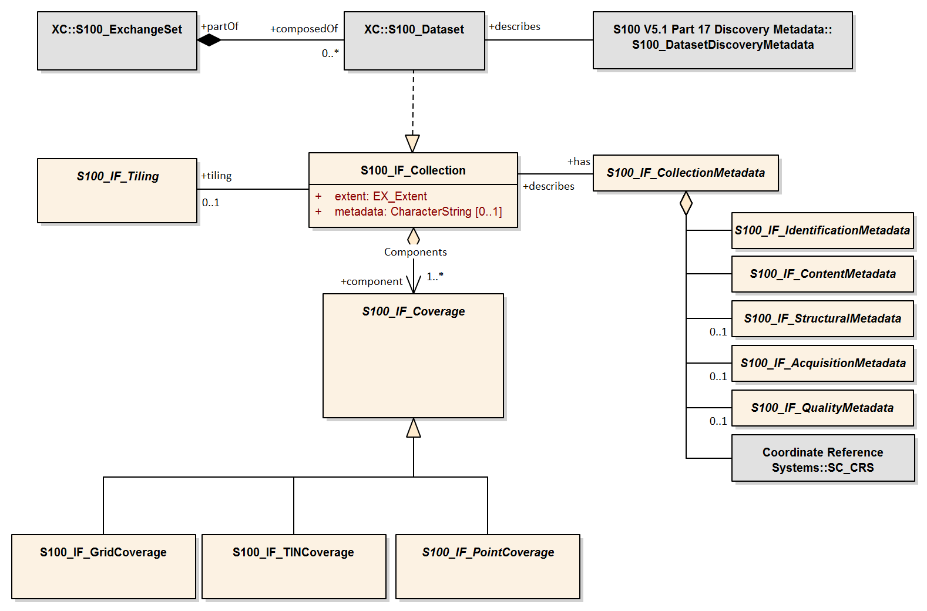
Figure 8-19 – Data Set Structure (adapted from ISO 19129:2009 Figure 7 - IGCD Structure and Metadata)

S100_Dataset
A dataset is an identifiable collection of data that can be represented in an exchange format or stored on a storage media. A dataset can represent all or a part of a logical data collection and may include one or many tiles of data. The content of a dataset is defined by the Product Specification for that particular type of data and is normally suited to the use of that data. A Product Specification for a particular data type needs to have a plan that indicates the organization of that data product. For example, a simple gridded bathymetry model based product may have only one bathymetry grid coverage, and a tiling scheme that indicates that every dataset contains one tile. More complex products may include several collocated coverages and more complex tiling schemes such as a quad tree based variable size tiling scheme, where one dataset may, at times contain more than one tile. The dataset is the logical entity that can be identified by the associated discovery metadata, not the physical entity of exchange.

S100_DatasetDiscoveryMetadata
Associated with a dataset is a set of discovery metadata that describes the dataset so that it can be accessed. It consists of the dataset discovery metadata defined in S-100 Part 17.

S100_ExchangeSet
The nominal transmittal for S-100 datasets is via Exchange Sets. An Exchange Set represents the physical entity of exchange. The transmittal is dependent upon the encoding format and the exchange media. A transmittal on a physical media such as a DVD may carry a number of datasets, whereas a transmittal over a low bandwidth telecommunications line may carry only a small part of a dataset. Any metadata carried with a transmittal is integral to the transmittal and may be changed by the exchange mechanism to other exchange metadata as required for the routing and delivery of the transmittal. A common exchange mechanism would be to carry a whole dataset on one physical media such as a CD-ROM. Transmittal metadata is not shown because any transmittal metadata, exclusive of the information in the S100_DatasetDiscoveryMetadata module, is dependent upon the mechanism used for exchange, and may differ from one exchange media or encoding format to another. An example of transmittal metadata would be counts of the number of data bytes in a unit of exchange.

S100_IF_Collection
An S100_IF_Collection represents a collection of data. A collection may include multiple different data types over a particular area, or multiple coverages of data of the same coverage type, but representing different surfaces. For example a collection may consist of a grid coverage and a point set over the same area, where the grid coverage represents a bathymetry surface and the point set a number of sounding points.
Table 8-1 — S100_IF_Collection
Role Name | Name | Description | Mult | Data Type | Remarks
Class | S100_IF_Collection | Collection of data | - | -
Attribute | extent | Spatiotemporal extent of the collection | 1 | EX_Extent
Attribute | metadata | Link to metadata in external file | 0..1 | CharacterString
Role | component | Coverages in the collection | 1..* | S100_IF_Coverage
Role | has | Metadata for the collection | 1 | S100_IF_CollectionMetadata
Role | tiling | Tiling scheme for the collection | 0..1 | S100_IF_Tiling

S100_IF_CollectionMetadata
Associated with an S100_IF_Collection is a set of collection metadata that describes the data product as represented in the collection. It consists of a number of sub-components that include S100_IF_StructuralMetadata, S100_IF_AcquisitionMetadata and S100_IF_QualityMetadata, as well as identification, coordinate reference system information, and dataset content. These metadata classes are descriptive metadata defined in ISO 19115-1, ISO 19115-2 and ISO 19157.
Table 8-2 — S100_IF_CollectionMetadata
Role Name | Name | Description | Mult | Data Type | Remarks
Class | S100_IF_CollectionMetadata | Metadata for all coverages in the dataset | - | -
Role | (component) | Identification information about the dataset | 1 | S100_IF_IdentificationMetadata | Product Specification, dataset issue date, etc
Role | (component) | Metadata about dataset content | 1 | S100_IF_ContentMetadata | Domain features and attributes
Role | (component) | Metadata about structure | 0..1 | S100_IF_StructuralMetadata
Role | (component) | Metadata about acquisition | 0..1 | S100_IF_AcquisitionMetadata
Role | (component) | Data quality information | 0..1 | S100_IF_QualityMetadata
Role | (component) | CRS information | 1 | SC_CRS | Attributes to identify the CRS

S100_IF_StructuralMetadata
Associated with a coverage data type is a set of structure metadata that describes the structure of the coverage or point set. This is an abstract class realized by S-100 Part 10c, where the structural metadata elements which are essential for S-100 coverage types are specified.

S100_IF_AcquisitionMetadata
Associated with a coverage data type is optionally one or many sets of acquisition metadata that describes the source of the data. This is an abstract class which may be realized by individual Product Specifications.

S100_IF_QualityMetadata
Associated with a coverage data type is optionally one or many sets of quality metadata that describes the quality of the data. This is an abstract class partially realized by S-100 Part 10c (as the uncertainty dataset in Table 10c-11) and partially in individual Product Specifications.

S100_IF_Coverage
This is an abstract class used to represent all of the types of coverage data that may occur in an S100_IF_Collection.
The subclasses of S100_IF_Coverage correspond to the types of coverages permitted for S-100 datasets. These classes are described in clause 8-7.

S100_IF_Tiling
This class is an abstract class used to describe the tiling scheme used with the S100_IF_Collection. Metadata identifying a particular instance of a tile is included in the S100_IF_StructuralMetadata module. Typical tiling schemes are described in clause 8-6.

S100_IF_IdentificationMetadata
Identification metadata for S-100 coverage datasets includes information about the Product Specification, issue data and time, geographic location identifier, etc. This is an abstract class realized in S-100 Part 10c.

S100_IF_ContentMetadata
This is an abstract class representing metadata about dataset content, in particular features and attributes as defined in the Feature Catalogue. It is realized in S-100 Part 10c.

SC_CRS
This class represents information about the coordinate reference system and datums (horizontal and vertical) used by the coverages. It is realized by attributes defined in S-100 Part 10c.

Tiling Scheme
Tiling is one method of reducing the volume of data in a dataset to manageable proportions. In a dataset there must be information both describing the tiling scheme and also about the instance of a tile or tiles carried in that particular dataset. The class S100_TilingScheme carries information about the tiling scheme as a whole. There may only be one tiling scheme defined for a particular data collection. Within a data warehouse (database) there may be several overlapping tiling schemes defined where any of the tiling schemes may be used as the basis of data extraction from the data warehouse.
A tiling scheme is itself a discrete coverage. It is normally a simple rectangular grid with tiles of equal density. Such a grid coverage may also be defined with tiles of variable density. A more complex tiling scheme may also be defined as a discrete polygon coverage. An example is a data collection consisting of elevation cut along political boundaries. These types of tiling schemes are illustrated in Figure 8-20. Other tiling schemes are also possible. In fact, any type of discrete coverage may be used to establish a tiling scheme.

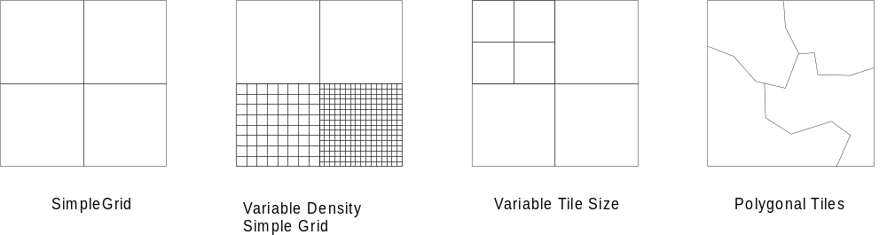

Figure 8-20 – Tiling scheme types
Any tiling scheme used must be completely described as part of the Product Specification for a particular data product. This includes the dimensions, location and data density of tiles as well as a tile identification mechanism (tileID).

Spatial Schema
Each of the S100_IF_Coverage subclasses has a specific Spatial Schema that describes the structure of that data type. The data types identified in clause 8-5.3 are:
- S100_IF_PointCoverage:
- S100_IF_TINCoverage; and
- S100_IF_GridCoverage.
The conceptual models of these coverage subclasses make use of point sets and geometry/value pairs, which are described by the classes S100_IF_PointSet and CV_GeometryValuePair and its subclasses.

S100_IF_PointSet spatial model
An S100_Point is a single point referenced to a 3-D coordinate reference system. Its value is carried as a coordinate rather than an attribute. Such points are generated by certain types of sensors. An S100_IF_PointSet is not a coverage. A Point Set can be used to generate a Point Coverage. The class S100_IF_PointSet is illustrated in Figure 8-21.

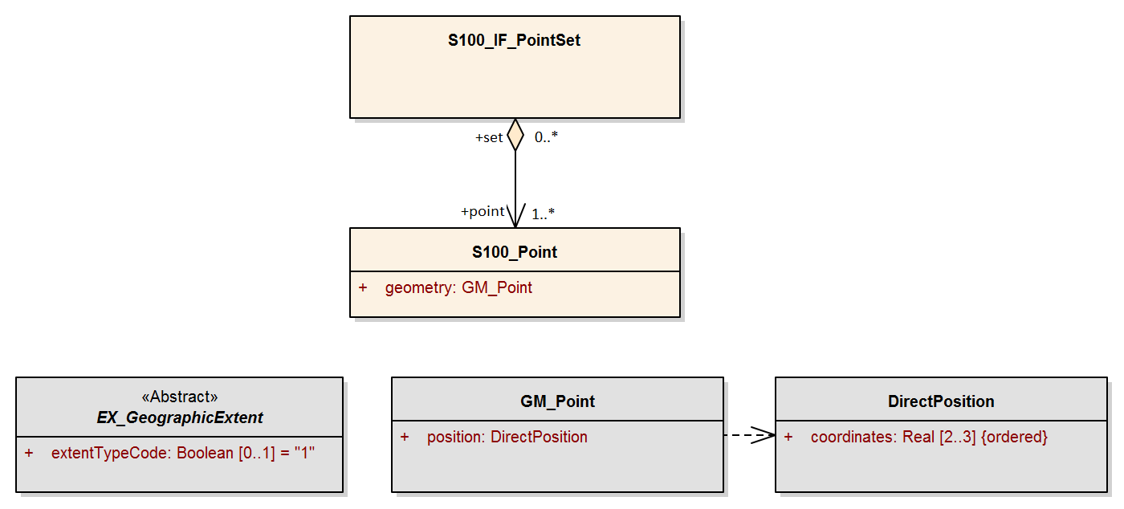
Figure 8-21 – S100_IF_PointSet
The attribute geometry contains an instance of GM_Point.

CV_GeometryValuePair and subclasses
The class CV_GeometryValuePair describes an element of a set that defines the relationships of a discrete coverage. Each member of this class consists of two parts: a domain object from the domain of the coverage to which it belongs; and a record of feature attribute values from the range of the coverage to which it belongs. CV_GeometryValuePair may be generated in the execution of an evaluate operation; and need not be persistent. CV_GeometryValuePair is subclassed (see clause 8-5) to restrict the pairing of a feature attribute value record to a specific subtype of domain object.
Table 8-3 — CV_GeometryValuePair
Role Name | Name | Description | Mult | Data Type | Remarks
Class | CV_GeometryValuePair | (S-100) 2-tuple of coverage spatial element and value record for that element | - | - | In S-100 this is an abstract model of the pairing between elements of a coverage and the associated values
Attribute | geometry | Spatial primitive | 1 | GM_Point  OR  CV_GridPoint | S-100 uses only points (including TIN vertices) or grid points as spatial elements of coverages
Attribute | value | Record of feature attribute values associated with this spatial object | 1 | RecordType

S-100 uses only two of the subclasses of CV_GeometryValuePair defined in ISO 19123:
- CV_PointValuePair, the subclass of CV_GeometryValuePair that has geometry = GM_Point and represents values at single points.
- CV_GridPointValuePair, the subclass of CV_GeometryValuePair that has geometry = CV_GridPoint and represents values at the grid points.
Table 8-4 — CV_PointValuePair
Role Name | Name | Description | Mult | Data Type | Remarks
Class | CV_PointValuePair | CV_PointValuePair is the subtype of CV_GeometryValuePair that has a GM_Point as the value of its geometry attribute | - | CV_GeometryValuePair
Attribute | geometry | Spatial primitive | 1 | GM_Point
Attribute | value | Value record | 1 | RecordType | Inherited from CV_GeometryValuePair  Must conform to rangeType

Table 8-5 — CV_GridPointValuePair
Role Name | Name | Description | Mult | Data Type | Remarks
Class | CV_GridPointValuePair | CV_GridPointValuePair is the subtype of CV_GeometryValuePair that has a CV_GridPoint as the value of its geometry attribute | - | CV_GeometryValuePair | Applies only to grid coverages
Attribute | geometry | Spatial primitive | 1 | CV_GridPoint
Attribute | value | Value record | 1 | RecordType | Inherited from CV_GeometryValuePair  Must conform to rangeType

S100_IF_PointCoverage spatial model
An S100_IF_PointCoverage is a type of CV_DiscretePointCoverage from ISO 19123. The attribute values in the value record for each CV_GeometryValuePair represent values of the coverage, such as bathymetric soundings.
The class S100_IF_PointCoverage (Figure 8-22) represents a set of values, such as bathymetric depth values, assigned to a set of arbitrary X,Y points. Each point is identified by a horizontal coordinate geometry pair (X,Y) and assigned one or more values as attribute values. These values are organized in a record for each point.

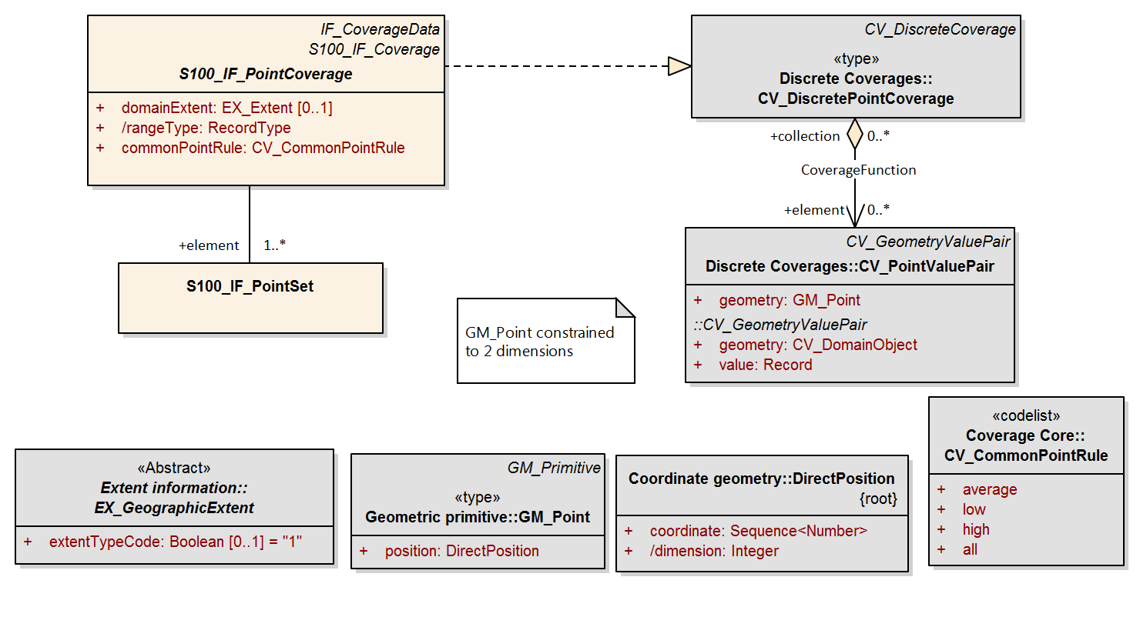
Figure 8-22 – S100_IF_PointCoverage
Table 8-6 — S100_IF_PointCoverage
Role Name | Name | Description | Mult | Data Type | Remarks
Class | S100_IF_PointCoverage | Spatial type for point coverages | - | -
Attribute | domainExtent | The spatiotemporal extent of the domain of the coverage | 0..1 | EX_Extent | Required only if the extent is different from the extent of the owning dataset  See Note 1
Attribute | rangeType | Describes the range of the coverage A list of name:data type pairs each of which describes an attribute type included in the range of the coverage | 1 | RecordType | Implemented externally as Feature Catalogue (S-100 Part 5) and feature information group (S-100 Part 10c)
Attribute | commonPointRule | Procedure used for evaluating the coverage at a position that falls on the boundary or in an area of overlap between geometric objects in the domain of the coverage | 1 | CV_CommonPointRule | The ISO values “start” and “end” are not used  See Note 2
Role | element | Spatial element | 1..* | S100_IF_PointSet

NOTE 1: domainExtent may be implemented as a geographic bounding box or bounding polygon with the temporal extent being implemented using separate attributes.
NOTE 2: The rule defined by attribute commonPointRule shall be applied to the set of values that results from evaluating the coverage with respect to each of the geometric objects that share a boundary. Appropriate values of the CV_CommonPointRule include ‘all’, 'average', 'high', and 'low'. For example, data used for bathymetric purposes may make use of the 'high' value (depending on the Z axis direction) to ensure that obstructions such as rocks or shoals are emphasised. In the case of discrete point coverages, commonPointRule is relevant only if a spatial query returns more than one point element of the coverage within the tolerance of the query.

S100_IF_TINCoverage spatial model
A TIN coverage is a type of CV_ContinousCoverage as described in ISO 19123. The attribute values in the value record for each CV_GeometryValuePair represent values for each of the vertex corners of the triangle. Any additional attributes related to a TIN triangle may be described as attributes of CV_ValueTriangle.
A TIN covers an area with a unique set of non-overlapping triangles where each triangle is formed by three points. The geometry for a TIN is described in ISO 19107 and a TIN coverage is described in ISO 19123. TIN coverages are particularly useful for representing elevation or bathymetry in some applications. It is easier to calculate an intersection with a coverage surface when it is represented as a TIN. The class S100_IF_TINCoverage is illustrated in Figure 8-23.
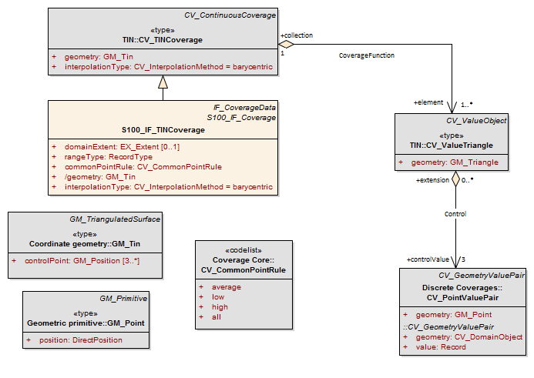
Figure 8-23 – S100_IF_TINCoverage
Table 8-7 — S100_IF_TINCoverage
Role Name | Name | Description | Mult | Data Type | Remarks
Class | S100_IF_TINCoverage | Spatial type for TIN coverages | - | -
Attribute | domainExtent | The spatiotemporal extent of the domain of the coverage | 0..1 | EX_Extent | Required only if the extent is different from the extent of the owning dataset  See Note 1
Attribute | rangeType | Describes the range of the coverage A list of name:data type pairs each of which describes an attribute type included in the range of the coverage | 1 | RecordType | Implemented externally as Feature Catalogue (S-100 Part 5) and feature information group (S-100 Part 10c)
Attribute | commonPointRule | Procedure used for evaluating the coverage at a position that falls on the boundary or in an area of overlap between geometric objects in the domain of the coverage | 1 | CV_CommonPointRule | The ISO values “start” and “end” are not used.  See Note 2
Attribute | interpolationType | The interpolation method to be used in evaluating the coverage | 1 | CV_InterpolationMethod | See Note 3
Attribute | geometry | Describes the network of triangles that form the basis of the TIN | 1 | GM_Tin | See Note 4

NOTE 1: domainExtent may be implemented as a geographic bounding box or bounding polygon with the temporal extent being implemented using separate attributes.
NOTE 2: The rule defined by attribute commonPointRule shall be applied to the set of values that results from evaluating the coverage with respect to each of the geometric objects that share a boundary. Appropriate values of the CV_CommonPointRule include ‘all’, 'average', 'high', and 'low'. For example, data used for bathymetric purposes may make use of the 'high' value (depending on the Z axis direction) to ensure that obstructions such as rocks or shoals are emphasised. The use of the commonPointRule occurs where a set of geometric objects are involved, such as the triangles in a TIN.
NOTE 3: The attribute interpolationType specifies the interpolation method recommended for the evaluation of the S100_IF_TINCoverage where the value is taken from the codelist CV_InterpolationMethod with the value "barycentric". The barycentric position S within a value triangle composed of the CV_PointValuePairs (P1, V1), (P2, V2), and (P3, V3), is (i, j, k), where S = iP1 + jP2 + kP3 and the interpolated attribute value at S is V = iV1 + jV2 +kV3.
NOTE 4: The triangles lie on a 2 dimensional manifold with the X,Y coordinates of the points at the vertices of the triangles representing the position on the manifold and the attribute. Three vertex points define a triangle. The attribute geometry for a TIN vertex is an instance of GM_Point. The attribute value contains a record restricted to one entry that defines the coverage value at the vertex (for example depth for a bathymetric TIN vertex point).

S100_IF_GridCoverage spatial model
The class S100_IF_GridCoverage (Figure 8-24 below) represents a set of values assigned to the points in a 2D grid. Several organizations of grids are available from ISO 19123 with different grid traversal orders, and variable or fixed grid cell sizes. S-100 makes use of two types of grid organizations, the simple quadrilateral grid with equal cell sizes traversed by a linear sequence rule, and the variable cell size quadrilateral grid traversed by a Morton Order sequence rule. This variable cell size grid organization is known as the Quad Tree for a two dimensional grid.
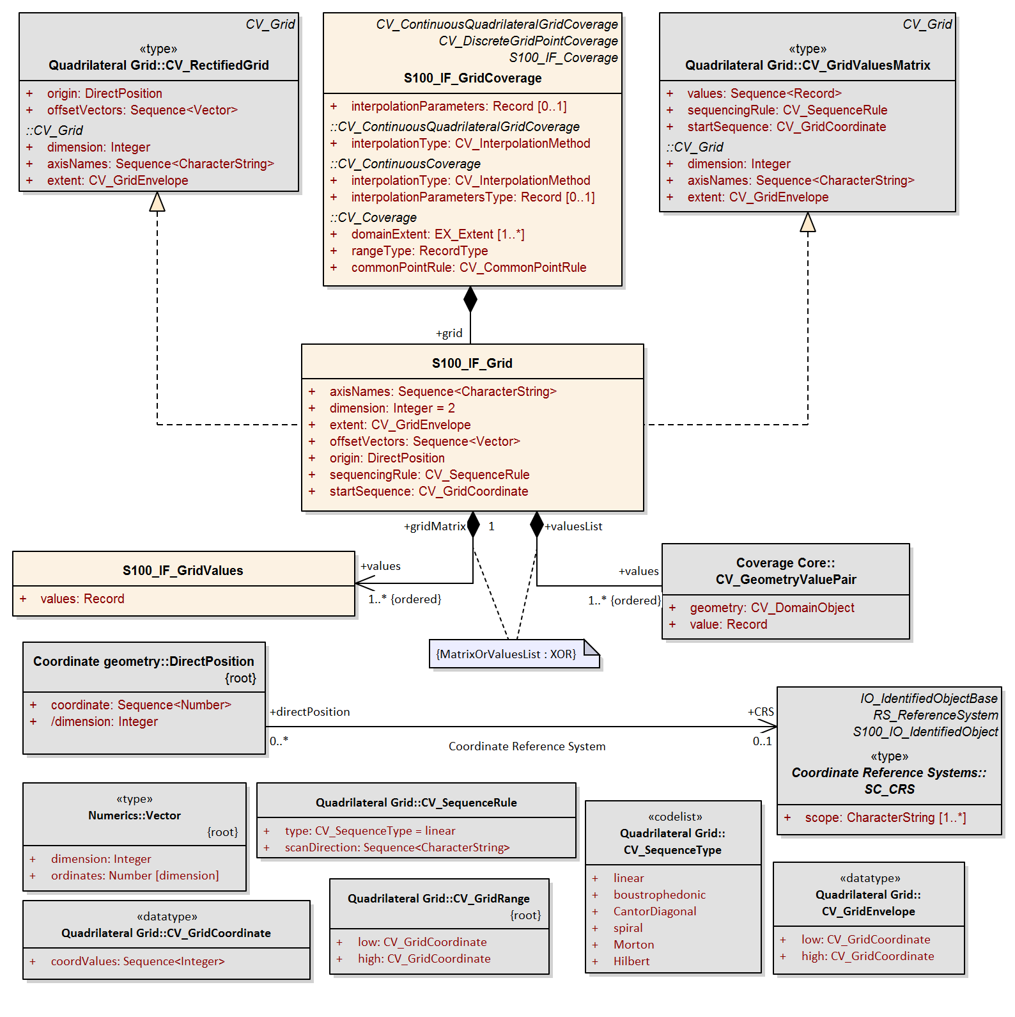
Figure 8-24 - S100_IF_GridCoverage
Table 8-8 — S100_IF_GridCoverage
Role Name | Name | Description | Mult | Data Type | Remarks
Class | S100_IF_GridCoverage | Coverage type for grid coverages | - | - | Subclasses both continuous and discrete grids
Attribute | domainExtent | The spatiotemporal extent of the domain of the coverage | 0..1 | EX_Extent | Required only if the extent is different from the extent of the owning dataset  See Note 1
Attribute | rangeType | Describes the range of the coverage A list of name:data type pairs each of which describes an attribute type included in the range of the coverage | 1 | RecordType | Implemented externally as Feature Catalogue (S-100 Part 5) and feature information group (S-100 Part 10c).
Attribute | commonPointRule | Procedure used for evaluating the coverage at a position that falls on the boundary or in an area of overlap between geometric objects in the domain of the coverage | 1 | CV_CommonPointRule | The ISO values “start” and “end” are not used  See Note 2
Attribute | interpolationType | The interpolation method to be used in evaluating the coverage | 1 | S100_CV_InterpolationMethod | See Note 3
Attribute | interpolationParameters | Holds the values of the parameters required to execute the interpolate operation specified by interpolationType | 0..1 | Record | Conditional in S-100 to interpolation methods ‘biquadratic’ and ‘bicubic’ only  Substitutes for ISO 19123 attribute interpolationParametersType
Composition | grid | The grid parameters, geometry, and values | 1 | S100_IF_Grid | A grid coverage must have grid geometry and values

NOTE 1: domainExtent may be implemented as a geographic bounding box or bounding polygon with the temporal extent being implemented using separate attributes. This attribute overrides the mandatory domainExtent inherited from CV_Coverage.
NOTE 2: The rule defined by attribute commonPointRule shall be applied to the set of values that results from evaluating the coverage with respect to each of the geometric objects that share a boundary. Appropriate values of the CV_CommonPointRule include ‘all’, 'average', 'high', and 'low'. For example, data used for bathymetric purposes may make use of the 'high' value (depending on the Z axis direction) to ensure that obstructions such as rocks or shoals are emphasised. The use of the commonPointRule occurs where a set of geometric objects are involved, such as the triangles in a TIN.
NOTE 3: The attribute interpolationType describes the interpolation method recommended for evaluation of the S100_IF_GridCoverage. The interpolation methods available are: Bilinear interpolation, Bicubic interpolation, Nearest-neighbour, and Biquadratic interpolation. These methods are defined in ISO 19123. Discrete point grids must use the special value for “no interpolation” added by S-100 (see S100_CV_InterpolationMethod).
The class S100_IF_Grid is a realization of CV_RectifiedGrid and CV_GridValuesMatrix from ISO 19123. The attributes inherit from the classes in ISO 19123.
Table 8-9 — S100_IF_Grid
Role Name | Name | Description | Mult | Data Type | Remarks
Class | S100_IF_Grid | Type for grid geometry and values | - | -
Attribute | axisNames | Names of the grid axes |  | <Sequence>CharacterString | Must be as in the EPSG Registry
Attribute | dimension | The dimension of the grid | 1 | Integer | Number of spatial dimensions, for example 2 for 2D grids
Attribute | extent | Area of the grid for which data are provided | 1 | CV_GridEnvelope | See Note 1
Attribute | offsetVectors | The spacing between grid points and the orientation of the grid axis with respect to the external coordinate reference system identified through the attribute origin | 1 | <Sequence>Vector
Attribute | origin | Coordinates of the grid origin with respect to an external coordinate system | 1 | DirectPosition
Attribute | sequencingRule | Method to be used to assign values from the sequence of values to the grid coordinates | 1 | CV_SequenceRule | See Notes 2, 3, 4
Attribute | startSequence | CV_GridCoordinate to specify the grid coordinates of the grid point to which the first in the sequence of values is to be assigned | 1 | CV_GridCoordinate | The choice of a valid point for the start sequence is determined by the sequencing rule
Composition | values | Sequence of Records each containing one or more values to be assigned to a single grid point | 1..* | S100_IF_GridValues  OR  CV_GeometryValuePair | See Note 5

NOTE 1: Grid coordinates of the corner of the area having the lowest grid coordinate values and the corner having the highest grid coordinate values. CV_GridCoordinate is specified in 19123 as a sequence of Integer values which identify a grid point, there being one integer value for each dimension of the grid. The ordering shall be the same as that of the elements of axisNames. The value of a single coordinate shall be the number of offsets from the origin of the grid in the direction of a specific axis.
NOTE 2: For simple grids with equal cell sizes, if data is not available for the whole area within this rectangle, then padding with null values shall be used to represent areas where no data is available. For variable cell size grids (Quad Tree grids) a characteristic of the Morton Order traversal is that nonrectangular areas may be represented. In this case the attribute extent is a bounding rectangle that encloses the area of the grid for which data are provided.
NOTE 3: Only the values "linear" (for a simple regular cell size grid) and "Morton" (for a Quad Tree Grid) shall be used for data that conforms to this standard. The sequence rule for a regular cell size grid is simple. When the cells are all of the same size, the cell index can be derived from the position of the Record within the sequence of Records. For a variable cell size grid the sequence order is more complex. The cell index either needs to be carried with each of the associated record values or it can be calculated based on each cell size.
NOTE 4: For simple grids with equal cell sizes the sequencingRule attribute of an S100_IF_Grid equals "linear" and the offset vector establishes the cell size. The attribute extent specifies the area of the grid for which data is provided. For variable cell size grids (Quad Tree grids) the sequencingRule attribute equals Morton and the offset vector establishes the minimum cell size. The actual cell size is included as an attribute in the data record that describes the level of aggregation of the quad structure. The attribute extent specifies a bounding rectangle within which data is provided. Which cells are included in the dataset is determined from the Morton ordered sequence of cells.
NOTE 5: Geometry (point coordinates in the form of an ordered point set) is provided only for grid types other than regular grid or variable cell size grids.
Table 8-10 — S100_IF_GridValues
Role Name | Name | Description | Mult | Data Type | Remarks
Class | S100_IF_GridValues | Type for grid values | - | -
Attribute | values | Ordered list of values for the feature attributes as specified in the feature catalogue | 1 | Record | See Notes 1 and 2

NOTE 1: Must conform to the RecordType specified by the rangeType attribute. If the value of an attribute is missing or unknown, a fill value must be used in its place.
NOTE 2: For simple grids with equal cell sizes the attribute values may be only data values, but for the variable cell size Quad Tree grid the record type shall include an index number and the cell size (aggregation level) for the cell.

Rectified or georeferenceable grids
The S100_IF_Grid model described in clause 8-7.5 is capable of representing rectified grids as well as referenceable grids. The model given below in Figure 8-25 below shows that a Grid can be of two types Rectified or Georeferenceable; and that the GridValuesMatrix is a subtype of the general grid object. The referenceable grid type is a subclass of CV_Grid and does not add attributes. The difference between georectified and georeferenceable grids lies in the operations for coordinate conversion:
- For georectified grids, the operation to map grid coordinates to direct positions uses the values of the attributes origin and offsetVectors in an affine transformation.
- For georeferenceable grids, the operation to map grid coordinates to direct positions is not defined in terms of origin and offset verctor. It there is no predefined association between one cell’s location and that of another; each cell’s location might be independently calculated.
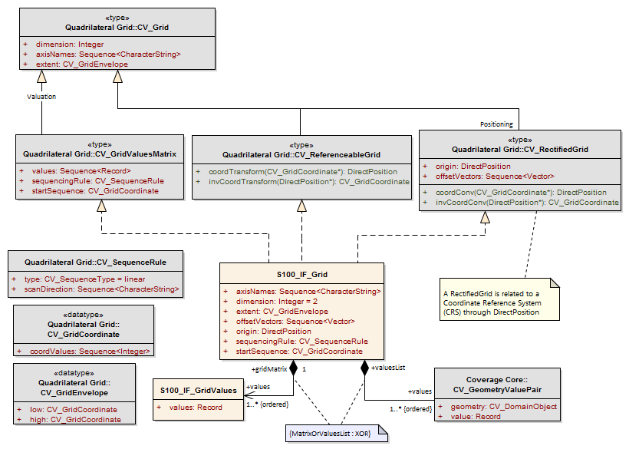
Figure 8-25 – Rectified or georeferenceable grids
A Rectified Grid is related to the Coordinate Reference System through the attribute origin, the orientation of the grid axes, and the spacing between the grid lines. For Rectified Grids, there is an affine relationship between the grid and the external coordinate system.
A Referenceable Grid may be related to a Coordinate Reference System through a Transform operation that allows the location of all points in the grid to be determined in the Coordinate Reference System, but the location of the points is not directly available from the grid coordinates; as opposed to a rectified grid where the location of the points in the Coordinate Reference System is derivable from the properties of the grid itself.
The S-100 model does not use coordinate transformations for georeferenceable grids. Instead, the Direct Positions of the grid points are encoded along with the value record for each grid point.

Common enumerations

CV_CommonPointRule
ISO 19123 states that “CV_CommonPointRule is a list of codes that identify methods for handling cases where the DirectPosition input to the evaluate operation falls within two or more of the geometric objects. The interpretation of these rules differs between discrete and continuous coverages. In the case of a discrete coverage, each CV_GeometryValuePair provides one value for each attribute. The rule is applied to the set of values associated with the set of CV_GeometryValuePairs that contain the DirectPosition. In the case of a continuous coverage, a value for each attribute shall be interpolated for each CV_ValueObject that contains the DirectPosition. The rule shall then be applied to the set of interpolated values for each attribute.”
Table 8-11 – CV_CommonPointRule enumeration
Item | Name | Description | Code | Remarks
Enumeration | CV_CommonPointRule | Codes that identify methods for evaluating the coverage at positions that fall on the boundary or in an area of overlap between geometric objects in the domain of the coverage | - | ISO 19123  CV_CommonPointRule
Literal | average | Return the mean of the attribute values | 1
Literal | low | Use the least of the attribute values | 2
Literal | high | Use the greatest of the attribute values | 3
Literal | all | Return all the attribute values that can be determined for the position | 4

NOTE: Use of ‘start’ and ‘end’ is prohibited for Product Specifications conforming to this edition of S-100, since segmented curves are not included among the coverages defined in Part 8 of this Edition.

CV_SequenceType
The scan methods are described in detail in ISO 19123. The order in which scanning takes place is the same as the order of axes in the attribute scanDirection. The starting location of the scan is given in the attribute startSequence.
NOTE: Product Specification authors and producers should take care that the start location is compatible with the sequence rule and scan direction; for example, linear sequencing would be incompatible with a start location at the upper bound of the grid bounding box and forward scan order in scanDirection.
Table 8-12 – CV_SequenceType enumeration
Item | Name | Description | Code | Remarks
Enumeration | CV_SequenceType | Codes that identify the method of ordering grid points or value records | - | ISO 19123 CV_ SequenceType
Literal | linear | Sequencing is consecutive along grid lines, starting with the first grid axis listed in scanDirection | 1 | For example, for 2-D grids with scan direction=(x,y), scanning will be in row-major order
Literal | boustrophedonic | Variant of linear sequencing in which the direction of the scan is reversed on alternating grid lines. For grids of dimension > 2, it is also reversed on alternating planes | 2
Literal | CantorDiagonal | Sequencing in alternating directions along parallel diagonals of the grid. For dimension > 2, it is repeated in successive planes | 3
Literal | spiral | Sequencing in spiral order | 4
Literal | Morton | Sequencing along a Morton curve | 5
Literal | Hilbert | Sequencing along a Hilbert curve | 6

Morton curves are generated by converting the grid coordinates (axial indexes) of each grid point to binary numbers and interleaving the binary digits of the results to produce the Morton code of the grid point. The method is documented in computer science textbooks as well as ISO 19123 and other accessible articles. Hilbert curves are more complex but descriptions are available in computer science and other reference texts (for example, the non-normative references in S-100 Part 10c).

S100_CV_InterpolationMethod
S100_CV_InterpolationMethod extends the ISO 19123 codelist CV_InterpolationMethod with the ‘discrete’ literal. The ISO 19123 CodeList CV_InterpolationMethod includes nine interpolation methods. Each is used in the context of specified grid types, indicated in the Remarks column. S-100 adds a ‘discrete’ literal for use when there is no interpolation.
Table 8-13 – S100_CV_InterpolationMethod enumeration
Item | Name | Description | Code | Remarks
Enumeration | S100_CV_InterpolationMethod | Codes for interpolation methods between known feature attribute values associated with geometric objects in the domain of the discrete coverage | - | Extension of ISO 19123 CV_ InterpolationMethod
Literal | nearestneighbor | Assign the feature attribute value associated with the nearest domain object in the domain of the coverage | 1 | Any type of coverage
Literal | bilinear | Assign a value computed by using a bilinear function of position within the grid cell | 5 | Only quadrilateral grids
Literal | biquadratic | Assign a value computed by using a biquadratic function of position within the grid cell | 6 | Only quadrilateral grids
Literal | bicubic | Assign a value computed by using a bicubic function of position within the grid cell | 7 | Only quadrilateral grids
Literal | barycentric | Assign a value computed by using the barycentric method described in ISO 19123 | 9 | Only TIN
Literal | discrete | No interpolation method applies to the coverage | 10 | Value added by S-100 to CV_InterpolationMethod

NOTE 1: The literals linear, quadratic, and cubic are prohibited since this Edition of S-100 does not include segmented curve coverages. The lostarea method is also omitted since this applies to Thiessen polygons which are not used in this Edition of S-100.
NOTE 2: Interpolation parameters, if needed, must be encoded in the interpolationParameters (see Table 8-8 in clause 8-7.5).

Data Spatial Referencing
Spatial referencing for gridded data and for point set data and TIN data are handled differently. Point set data includes a coordinate direct position for each point in the point set. TIN data includes a point at each vertex of a TIN triangle. Spatial referencing of direct positions is described in ISO 19111 Spatial referencing by coordinates, and is the same for point set, and TIN data as it is for other types of vector data. Gridded data references the grid as a whole.

Gridded data spatial referencing
The two spatial properties of gridded data describe how the spatial extent was tessellated into small units and spatial referencing to the earth. The ISO 19123 standard indicates that a grid may be defined in terms of a coordinate reference system. This requires additional information about the location of the grid’s origin within the coordinate reference system, the orientation of the grid axes, and a measure of the spacing between the grid lines. A grid defined in this way is called a rectified grid. If the coordinate reference system is related to the Earth by a datum, the grid is a georectified grid. The essential point is that the transformation of grid coordinates to coordinates of the external coordinate reference system is an affine transformation. The class SC_CRS is specified in ISO 19111. A referenceable grid is one that can be converted to a rectified grid by a coordinate transform.

Georectified
Georectified gridded data is uniformly spaced gridded data. Any cell in a georectified gridded data can be uniquely geolocated, given the cell spacing, grid origin and orientation. In most georectified gridded data, cell size is constant across the whole coverage and also equates to the cell spacing. (Note, however, that uniformly spaced gridded data may be uniformly spaced in terms of image coordinates, and not geolocatable.) For georectified gridded data, information as simple as the map coordinate values of any two cells not in the same row and column can geolocate all cells in the coverage to the map coordinate system, since cell spacing, grid origin and orientation can be derived from the coordinates of the two cells.
It should be pointed out that the cell spacing (that is, cell size) in the above definition is the distance measured at the map projection coordinate system. Uniform spacing in a map coordinate system may not necessarily indicate equal spacing on the earth’s surface, depending on the map projection selected. For example, a cell size of 0.1 degree longitude in the geographic coordinate system (that is lat/long) corresponds to different surface distances in kilometres at high and low latitudes.
The term “uniform spacing” means that there is equal spacing in some defined coordinate system. “Regular spacing” means that there is some function that equates location to cell spacing.
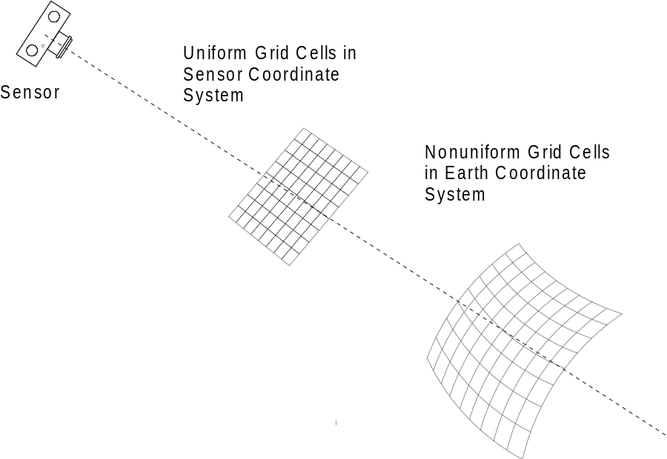
Figure 8-26 – Non uniform spacing of grid cells

Ungeorectified
Ungeorectified gridded data is geospatial gridded data whose cells are non-uniformly spaced in any geographic/map projection coordinate system. Therefore, the location of one cell in an ungeorectified gridded data cannot be determined based on another cell’s location.
Ungeorectified gridded data can be further classified into georeferenced and georeferenceable subclasses, depending on whether information is provided with a dataset that allows determination of the geolocation of a cell.

Georeferenced
Georeferenced gridded data is gridded data whose cell locations can be uniquely determined through certain geolocating algorithms, such as warping, using information provided with the data. Most raw remote sensing data and raw hydrographic sonar data are in the georeferencaeble form.

Sensor
Georeferenced Grid Data
Transform
Georeferenceable grid data
Figure 8-27 – Georectified data

Georeferenceable
Georeferenceable gridded data is ungeorectified gridded data that does not include any information that can be used to determine a cell’s geographic coordinate values, for example, a digital perspective aerial photograph without georectifiction information included. (An aerial photograph can be georeferenced through a set of ground control points.)
The difference between georectified and georeferenced data is that cell spacing is constant in a georectified data while it may be variable in georeferenced data. In georectified data, the location of any cell can be determined given the data’s cell spacing, grid orientation and the coordinates of any one cell. In georeferenced data, there is no predefined association between one cell’s location and that of another; each cell’s location might be independently calculated. Georectified gridded data are normally obtained from georeferenced data through georectification (also called geometric correction). The georectification process involves two steps. The first step is to calculate the grid coordinates (for example row and column) of regularly spaced cells located at the map coordinate x, y. This step is called coordinate mapping. The second step is to assign the cell with an attribute value based on the attribute values at the corresponding and neighbouring grid coordinates. This step is called resampling. Spatial referencing information for imagery data is carried as metadata.

Point set data and TIN triangle vertex spatial referencing
Point sets and TIN triangles are described in the ISO Spatial Schema standard 19107, which has been profiled as part of S-100. Each point in a point set is located by a direct position. The spatial referencing system that relates to the direct positions in the set is referenced by the Spatial Schema, through the same SC_CRS object.

Metadata

The metadata for all types of geographic data is covered in the metadata standard ISO 19115-1 Geographic information - Metadata. This standard includes mandatory identification metadata that describes the data set. It also includes some metadata describing the content of a data set. Much of the metadata corresponding to vector based geometric data does not apply to imagery and gridded data.
S-100 uses the metadata elements in ISO 19115-1, where possible, to address the basic metadata requirements for geographic data, including Imagery, Gridded, and Coverage data. Other metadata elements primarily related to acquisition and processing are addressed in ISO 19115-2 Geographic information - Metadata - Part 2: Extensions for imagery and gridded data. Quality metadata is described in ISO 19157 Geographic information - Data Quality. The minimum amount of metadata required to describe geographic data is addressed in ISO 19115-1. The details of sensor models and their associated data models and metadata are provided in ISO 19130 Geographic information - Sensor and data models for imagery and gridded data.
Metadata for S-100 is described in S-100 Parts 4a-4c. The specific metadata for S-100 Imagery and Gridded Data is shown in Appendix 8-D. The data format representations for S-100 metadata are described in S-100 Parts 10c and 17.
Suggested metadata supporting a scanned paper chart in compliance with S-61 is described in Appendix 8-D (clause Metadata for Scanned Image).

Quality
The general concept for handling quality in the ISO 19100 series of standards is defined in the ISO 19113 “Quality principles”. The procedures to evaluate quality are defined in the ISO 19114 “Quality evaluation procedures”. ISO 19138:2006 “Data quality measures” provides a definitive set of measures. The metadata quality elements from ISO 19115:2003 have been moved to a new standard ISO 19157:2013 Geographic information -- Data quality.
The ISO 19129 standardizes quality aspects that are specific for imagery, gridded, and coverage data. The testing of the quality according to this standard is model based. The quality measures are attributes or constraints of the classes of the model. Appendix 8-C shows the proposed top-level classes of the quality model.

Imagery and Gridded Data Portrayal
The mechanism for portrayal is out of scope for this component of S-100. It is described in the Portrayal component of S-100 Parts 9 and 9a. The basic mechanism for feature centric rule based portrayal is given in ISO 19117 “Portrayal”. However, certain information may need to be carried with a set of imagery and gridded data to support external portrayal mechanisms.

Imagery and Gridded Data Encoding
Details of encoding are out of scope of this component of S-100. The standard S-100 encoding for coverage datasets is described in S-100 Part 10c. An S-100 standard for “picture/image” encoding has not been defined as yet, but the References clause in this Part and the list of allowed support file formats in S-100 Part 17 may be consulted for hints on formats which may be of use.

Feature Oriented Image
All gridded datasets are feature oriented, in that a coverage is a subtype of a feature. That is an entire gridded dataset can be considered to be a single feature. A feature structure can be applied to gridded data in two different ways. First, a discrete coverage can carry a feature code as an attribute. For example, a coverage corresponding to the postal code system will have discrete values for each postal code, yet still cover the country completely. The only difference in the Application Schema is a relationship between the discrete coverage and the feature. This is shown in Figure 8-28.
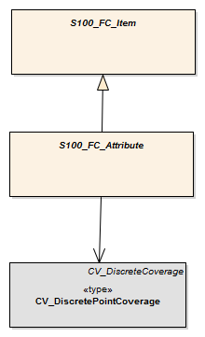
Figure 8-28 – Feature oriented discrete coverage
The second method of establishing a feature structure is to develop a composite dataset that contains many separate but adjoining coverages. The coverages may be continuous or discrete. This is very much like the way a "vector" data set is composed where each feature has its own geometry and attributes. In fact vector data may be mixed with coverage data in the same dataset. The Application Schema simply allows multiple instances of features.
Geometric elements such as grids may be shared between multiple features, and features may be related by composition or other relationships as allowed in the general feature model of ISO 19109. A complex feature may include both a continuous grid coverage and vector data such as a polygonal boundary. A feature oriented dataset may contain both a continuous coverage of the ocean as collected by sonar, and point and line features corresponding to navigational aids. Topological primitives may relate all of the features. This allows for some interesting and useful structures.
A Raster Nautical Chart may include additional vector data describing the navigational aids, hazards and danger zones, which is not "visible" in that it is not portrayed, but which is active in the use of the Raster Nautical Chart, so a ship can determine whether it is within a danger zone, or perform some other ECDIS-like functions.
See Appendix 8-E for additional information about Feature Oriented Gridded Data.

Appendix 8-A
Abstract Test Suite
(normative)

  - Quadrilateral Grid
- Test Purpose: Verify that an Application Schema instantiates the classes defined in ISO 19123 of CV_Grid, CV_GridPoint, CV_GridCell, CV_GridValuesMatrix, CV_GridPointValuePair, CV_DiscreteGridPointCoverage, or CV_ContinuousGridCoverage, and CV_GridValueCell with their specified attributes, operations, associations and constraints, in the context of the classes S100_IF_GridCoverage, S100_IF_Grid and S100_IF_GridValues as defined in this Standard
- Test Method: Inspect the documentation of the Application Schema or profile.
- Reference: ISO 19123, Clause 8.
- Test Type: Capability.

  - Scanned Image
- Test Purpose: Verify that an Application Schema for Raster Scan Image satisfies the requirements of A.1; that it includes the metadata elements identified in Table 8-D-3.
- Test Method: Inspect the documentation of the Application Schema or profile.
- Reference: ISO 19115-1, IHO S-61.
- Test Type: Capability.

  - TIN Coverage
- Test Purpose: Verify that an Application Schema for TIN Coverage instantiates the classes defined in ISO 19123 of CV_TINCoverage, CV_ValueTriangle, and CV_GridPointValuePair with their specified attributes, operations, associations and constraints, in the context of the class S100_IF_TINCoverage as defined in this Standard.
- Test Method: Inspect the documentation of the Application Schema or profile.
- Reference: ISO 19123
- Test Type: Capability.

  - Point Coverage
- Test Purpose: Verify that an Application Schema for Point Coverage instantiates the classes defined in ISO 19123 of CV_DiscretePointCoverage, and CV_PointValuePair, with their specified attributes, operations, associations and constraints, in the context of the class S100_IF_PointCoverage as defined in this Standard.
- Test Method: Inspect the documentation of the Application Schema or profile.
- Reference: ISO 19123
- Test Type: Capability.

  - Point Set
- Test Purpose: Verify that an Application Schema for Point Set instantiates the classes defined in ISO 19107 of GM_Point, with its specified attributes, operations, associations and constraints, in the context of the classes S100_IF_PointSet and S100_Point as defined in this Standard.
- Test Method: Inspect the documentation of the Application Schema or profile.
- Reference: ISO 19107
- Test Type: Capability.

  - Variable Cell Size Grid
- Test Purpose: Verify that an Application Schema for Variable Cell Size instantiates the classes defined in ISO 19123 of CV_Grid, CV_GridPoint, CV_GridCell, CV_GridValuesMatrix, CV_GridPointValuePair, CV_DiscreteGridPointCoverage, or CV_ContinuousGridCoverage, and CV_GridValueCell with their specified attributes, operations, associations and constraints, with the CV_ContinuousCoverage CV_InterpolationMethod attribute set to NearestNeighbour and the CV_GridValuesMatrix CV_SequenceRule attribute set to (x,y) Morton.
- Test Method: Inspect the documentation of the Application Schema or profile.
- Reference: ISO 19123
- Test Type: Capability.

  - Feature Oriented Image Discrete Coverage
- Test Purpose: Verify that an Application Schema for Feature Oriented Image that uses a discrete coverage instantiates the classes defined in ISO 19123 of CV_Grid, CV_GridPoint, CV_GridCell, CV_GridValuesMatrix, CV_GridPointValuePair, CV_DiscreteGridPointCoverage, CV_DiscreteCoverage, and CV_GeometryValuePair with their specified attributes, operations, associations and constraints.
- Test Method: Inspect the documentation of the Application Schema or profile.
- Reference: ISO 19123, 19109
- Test Type: Capability.

  - Feature Oriented Image in a Multi-feature Environment
- Test Purpose: Verify that an Application Schema instantiates the classes defined in ISO 19123 of CV_Grid, CV_GridPoint, CV_GridCell, CV_GridValuesMatrix, CV_GridPointValuePair, CV_DiscreteGridPointCoverage, or CV_ContinuousGridCoverage, and CV_GridValueCell with their specified attributes, operations, associations and constraints, and that multiple features are permitted with separate CV_Coverages or GM_Objects.
- Test Method: Inspect the documentation of the Application Schema or profile.
- Reference: ISO 19123, 19109, 19107
- Test Type: Capability

Appendix 8-B
Terminology
(informative)

The terminology used in S-100 aligns with the terminology used in the ISO 19100 suite of standards and it is different from that used in S-57. S-57 uses the terms “raster” and “matrix” to address images and data described by organized sets of attribute values. The ISO 19100 suite of standards has a more rigorous definition of terms, but these new terms include much more that is normally thought of as "Raster" or "Matrix" data. Unfortunately current terms in this field have been used with broad overlapping meanings and the terminology can be confusing.
One of the most misused terms is “raster”. Technically the term describes the row by column scanning of a regular rectangular grid, such as the raster scan of a television screen. A raster is a type of a grid. However, often the term is used in a very broad sense to mean most, but not all types of data that cover an area. S-100 now makes use of the term “raster” in its more precise technical sense as a traversal method for a grid of data.
“matrix” is a term that is also used in different ways in different contexts. It is sometimes colloquially used to address all gridded data that corresponds to measurements from non-imaging sensors. But what is an imaging sensor? What is an image? Anything that can be "seen" is thought of as being an image. But a graph of measured data such as elevations, even a two-dimensional graph of data, can be seen. In fact visualization is the purpose of graphing. The term “matrix” also has a mathematical meaning of being an organized set of numbers. The current colloquial meaning of the term “matrix” has been abandoned in this edition of S-100, and the mathematical meaning of an ordered set of numbers is retained as the meaning for the word.
ISO begins defining its terminology by defining a "coverage". In TC211, a coverage is defined as a "function to return one or more feature attribute values for any direct position within its spatiotemporal domain". For a continuous coverage any position in the spatiotemporal domain has a value. A coverage function is basically an interpolation function over a set of grid points or other points covering an area. This makes a coverage the inverse of what is normally thought of as a set of gridded data. Data collected from a sensor creates a values matrix that drives the coverage function. This set of values may be organized in several ways. The simplest is a regular grid, but there may be other organizations of grids such as tiled grids or irregular shaped grids. There may even be grids with variable size cells in multi-dimensions that have been shown to be quite effective in handling hydrographic sounding data. The ISO 19123 standard defines a Grid Value Matrix, TIN Value Triangle, Segmented-Curve Value Curves, and Thiessen Value Polygons as the base elements for the set of data sampled from a sensor. This component of S-100 only needs the concept of a grid value matrix, and does not need to address Segmented Curves, or Thiessen Polygons.
The terms Imagery, Gridded and Coverage data are not mutually exclusive terms. Imagery is a type of Gridded data and Gridded data is a type of Coverage data. Coverage is the broad term. Grid describes one organization of the matrix of data supporting a coverage function. An image is data that may be "viewed".
S-100 needs to use terminology in alignment with ISO and other external standards. However it also needs to recognize the uses of terms in previous editions of S-57. A raster is a grid traversal method. Therefore “Raster Image Data” means data organized as a set of grid value matrix points representing an image. “Raster Image Data” corresponds generally to the term Raster Data as used in S-57 edition 3. Gridded data is all data organized as a set of grid value matrix points. Therefore “Gridded Data” corresponds generally to the term Matrix Data as used in S-57 Edition 3.

Page intentionally left blank

Appendix 8-C
Quality Model for Imagery and Gridded Data
(informative)

The following is a list of quality elements test procedures that addresses imagery. Quality elements for gridded and coverage data are described in S-100 Part 4c and S-97 Part C.

- Top-level classes of the quality-model
General image quality
Visual inspection and evaluation of image geometry
Analytical inspection and evaluation of image geometry
Visual inspection and evaluation of image radiometry
Analytical inspection and evaluation of image radiometry
The following listings are non-exhaustive listings of the subclasses of the quality model.

- Class General image quality
check parameters affecting the quality (data compression etc.)
make test scanning or test imaging

- Class Visual inspection and evaluation of image geometry
check number of channels (black&white, colour, multispectral, etc.)
check edge-matching
check event of blurring
check rectification errors
check “pixel-stretching”
check overlay with vector data (other mapping data, map-frame)
check overlay with other raster or gridded data
identify source of data
inspect documentation of the quality of the sensor or the scanner (calibration data)
inspect documentation of previous processing step (image enhancements)
check resolution of imaged test patterns

- Class Analytical inspection and evaluation of image geometry
check seam lines of mosaics
check colour stability / homogeneity / balance
check grade of illumination of the image (hot spot)
check histogram
check coloured fringes along lines with high contrast

- Class Visual inspection and evaluation of image radiometry
calculate geometric residuals at checkpoints in 2D and/or in 3D
calculate residuals in range at checkpoints

- Class Analytical inspection and evaluation of image radiometry
calculate contrast
calculate brightness

Page intentionally left blank

Appendix 8-D
Metadata
(informative)

  - Typical metadata
Typical metadata elements that are used in imagery, gridded and coverage data are presented in Table 8-D-1 below. The Table organizes the metadata elements according to whether the metadata relates to the description of the imagery, gridded or coverage data content; or to the environment in which it exists; or the representation of the data. Additional representational metadata may exist in an encoding format.
Table 8-D-1 – Metadata Elements
Type (Metadata Package) | Description | Relationship
Metadata Elements (19115-1)
Metadata information | Metadata information | Environment
Identification information | Information to uniquely identify the data. Identification information includes information about the citation for the resource, an abstract, the purpose, credit, the status and points of contact | Environment
Constraint information | Information concerning the restrictions placed on data | Environment
Data quality information (ISO 19157) | Assessment of the quality of the data | Content
Maintenance information | Information about the scope and frequency of updating data | Environment
Spatial representation information | Information concerning the mechanisms used to represent spatial information | Content
Reference system information | The description of the spatial and temporal reference system(s) | Content
Content information | Information identifying the Feature Catalogue | Content
Portrayal Catalogue information | Information identifying the Portrayal Catalogue | Representation
Distribution information | Information about the distributor of, and options for obtaining, a resource | Environment
Metadata extension information | Information about user specified extensions | Various
Application Schema information | Information about the Application Schema used to build a dataset | Content
Metadata Imagery Extensions per 19115-2
Content Information Imagery | Additional information used to identify the content of coverage data | Content
Identification Information Imagery | Information to uniquely identify the data, including extensions to describe references that apply to the data and entities to identify the components used to acquire the data | Environment
Requirements Information Imagery | Provides details specific to the tasking and planning associated with the collection of imagery and gridded data | Environment
Acquisition Information Imagery | Information on the acquisition of imagery and gridded data
Data Quality Information Imagery | Assessment of the quality of the imagery data | Content
Spatial Representation Information Imagery | Additional information the mechanisms used to represent spatial information for imagery | Content
Metadata Datatypes
Extent information | Metadata elements that describe the spatial and temporal Extent - “geographicElement”, “temporalElement”, and “verticalElement | Content
Extent Information Imagery | Defines additional attributes used to specify the location of the minimum and maximum vertical extent values within the dataset | Content
Citation and responsible party information | A standardized method (CI_Citation) for citing a resource (dataset, feature, source, publication, etc.), as well as information about the party responsible (CI_Responsibility) for a resource | Environment

  - Derivation of S-100 metadata and ISO metadata
Metadata for S-100 is taken where possible from the ISO 19115-1 Metadata standard to ensure a high level of compatibility with other standards based on the same metadata standard. This metadata has been organized into a number of packages. The following is a list of the packages defined in ISO 19115-1.
Table 8-D-2 – Relationship between packages of metadata and metadata classes
Package | Class
Metadata information | MD_Metadata
Identification information | MD_Identification
Constraint information | MD_Constraints
Data quality information | DQ_DataQuality (ISO 19157)
Maintenance information | MD_MaintenanceInformation
Spatial representation information | MD_SpatialRepresentation
Reference system information | MD_ReferenceSystem
Content information | MD_ContentInformation
Portrayal Catalogue information | MD_PortrayalCatalogueReference
Distribution information | MD_Distribution
Metadata extension information | MD_MetadataExtensionInformation
Application Schema information | MD_ApplicationSchemaInformation
Extent information | EX_Extent
Citation and responsible party information | CI_Citation  CI_Responsibility

ISO TC211 has also completed ISO 19115-2 Geographic information - Metadata - Part 2: Extensions for imagery and gridded data. It contains additional packages for MI_AcquisitionInformation, Lineage (Source and Process), Quality result for Coverage (QE_CoverageDescription) and usability (QE_Usability) that are relevant for the description of Imagery and Gridded data in S100.
The MI_AcquisitionInformation package provides details specific to the acquisition of imagery and gridded data. It contains:
- MI_Instrument, designations of the measuring instruments used to acquire the data;
- MI_Operation, designations of the overall data gathering program to which the data contribute;
- MI_Platform, designations of the platform from which the data were taken;
- MI_Objective, the characteristics and geometry of the intended object to be observed;
- MI_Requirement, the user requirements used to derive the acquisition plan;
- MI_Plan, the acquisition plan that was implemented to acquire the data;
- MI_Event, describes a significant event that occurred during data acquisition. An event can be associated with an operation, objective, or platform pass; and
- MI_PlatformPass, identifies a particular pass made by the platform during data acquisition. A platform pass is used to provide supporting identifying information for an event and for data acquisition of a particular objective.

The additional classes to address the sources and production processes of particular importance for imagery and gridded data are:
- QE_CoverageResult is a specified subclass of DQ_Result and aggregates information required to report data quality for a coverage;
- QE_Usability is a specified subclass of DQ_Element used to provide user specific quality information about a dataset’s suitability for a particular application;
- LE_ProcessStep is a specified subclass of LI_ProcessStep and contains additional information on the history of the algorithms used and processing performed to produce the data. It includes a description of:
      - LE_Processing, which describes the procedure by which the algorithm was applied to generate the data from the source data;
      - LE_ProcessStepReport which identifies external information describing the processing of the data;
      - LE_Source,which describes the output of a process step.

  - Metadata class information (MD_Metadata) from ISO 19115-1 and ISO 19157
The MD_Metadata class is an aggregate of the following classes (which are further explained in the following subclauses):
- Identification information (MD_Identification)
Identification information contains information to uniquely identify the data. It includes information about the citation for the resource, an abstract, the purpose, credit, the status and points of contact. The MD_Identification entity is mandatory. It contains mandatory, conditional, and optional elements. MD_Identification is an aggregate of the following entities:
- MD_Format, format of the data;
- MD_BrowseGraphic, graphic overview of the data;
- MD_Usage, specific uses of the data;
- MD_Constraints, constraints placed on the resource;
- MD_Keywords, keywords describing the resource; and
- MD_MaintenanceInformation, how often the data is scheduled to be updated and the scope of the update.
- Constraint information (MD_Constraints)
This package contains information concerning the restrictions placed on data. The MD_Constraints entity is optional and may be specified as MD_LegalConstraints and/or MD_SecurityConstraints. The otherConstraint element of MD_LegalConstraints shall be non-zero (used) only if accessConstraints and/or useConstraints elements have a value of “otherRestrictions”, which is found in the MD_RestrictionCode enumeration.
- Data quality information (DQ_DataQuality – ISO 19157)
This package contains a general assessment of the quality of the dataset. The DQ_DataQuality entity is optional and contains the scope of the quality assessment. DQ_DataQuality is an aggregate of LI_Lineage and DQ_Element. DQ_Element can be specified as DQ_Completeness, DQ_LogicalConsistency, DQ_PositionalAccuracy, DQ_ThematicAccuracy and DQ_TemporalAccuracy. Those five entities represent Elements of data quality and can be further subclassed to the sub-Elements of data quality. Users may add additional elements and sub-elements of data quality by sub-classing DQ_Element or the appropriate sub-element.
This package also contains information about the sources and production processes used in producing a dataset. The LI_Lineage entity is optional and contains a statement about the lineage. LI_Lineage is an aggregate of LI_ProcessStep and LI_Source. The “report” and “lineage” roles of DQ_DataQuality are mandatory if DQ_DataQuality.scope.DQ_Scope.level has a value of “dataset”. The “levelDescription” element of DQ_Scope is mandatory if the “level” element of DQ_Scope does not have a value of “dataset” or “series”. The "statement" element of LI_Lineage is mandatory if DQ_DataQuality.scope.DQ_Scope.level has a value of "dataset" or "series" and the LI_Lineage roles of "source" and "processStep" are not documented.
The “source” role of LI_Lineage is mandatory if the “statement” element and the “processStep” role of LI_Lineage are not documented. The “processStep” role of LI_Lineage is mandatory if the “statement” element and the “source” role of LI_Lineage are not documented. Either the “description” or “sourceExtent” element of LI_Source must be documented.
- Maintenance information (MD_MaintenanceInformation)
This package contains information about the scope and frequency of updating data. The MD_MaintenanceInformation entity is optional and contains mandatory and optional metadata elements.
- Spatial representation information (MD_SpatialRepresentation)
This package contains information concerning the mechanisms used to represent spatial information in a dataset. The MD_SpatialRepresentation entity is optional and can be specified as MD_GridSpatialRepresentation and MD_VectorSpatialRepresentation. Each of the specified entities contains mandatory and optional metadata elements. When further description is necessary, MD_GridSpatialRepresentation may be specified as MD_Georectified and/or MD_Georeferenceable. Metadata for Spatial data representation are derived from ISO 19107.
- Reference system information (MD_ReferenceSystem)
This package contains the description of the spatial and temporal reference system(s) used in a dataset. MD_ReferenceSystem contains an element to identify the reference system used. MD_ReferenceSystem may be subclassed as MD_CRS, which is an aggregate of MD_ProjectionParameters and MD_EllipsoidParameters. MD_ProjectionParameters is an aggregate of MD_ObliqueLineAzimuth and MD_ObliqueLinePoint. MD_ReferenceSystem is derived from RS_ReferenceSystem, which can be specified as SC_CRS, SI_SpatialReferenceSystemUsingGeographicIdentifiers and TM_ReferenceSystem. Metadata for Reference system information are derived from ISO 19108, ISO 19111 and ISO 19112.
- Content information (MD_ContentInformation)
This package contains information identifying the Feature Catalogue used (MD_FeatureCatalogueDescription) and/or information describing the content of a coverage dataset (MD_CoverageDescription). Both description entities are subclasses of the MD_ContentInformation entity. MD_CoverageDescription may be subclassed as MD_ImageDescription, and is an aggregate of MD_RangeDimension. MD_RangeDimension may additionally be subclassed as MD_Band.
- Portrayal Catalogue information (MD_PortrayalCatalogueReference)
This package contains information identifying the Portrayal Catalogue used. It consists of the optional entity MD_PortrayalCatalogueReference. This entity contains the mandatory element used to specify which Portrayal Catalogue is used by the dataset.
- Distribution information (MD_Distribution)
This package contains information about the distributor of, and options for obtaining, a resource. It contains the optional MD_Distribution entity. MD_Distribution is an aggregate of the options for the digital distribution of a dataset (MD_DigitalTransferOptions), identification of the distributor (MD_Distributor) and the format of the distribution (MD_Format), which contain mandatory and optional elements. MD_DigitalTransferOptions contains the medium used for the distribution (MD_Medium) of a dataset, and is an aggregate of MD_DigitalTransferOptions. MD_Distributor is an aggregate of the process for ordering a distribution (MD_StandardOrderProcess).
The “distributionFormat” role of MD_Distribution is mandatory if the “distributorFormat” role of MD_Distributor is not documented. The “distributorFormat” role of MD_Distributor is mandatory if the “distributionFormat” role of MD_Distribution is not documented.
- Metadata extension information (MD_MetadataExtensionInformation)
This package contains information about user specified extensions. It contains the optional MD_MetadataExtensionInformation entity. MD_MetadataExtensionInformation is an aggregate of information describing the extended metadata elements (MD_ExtendedElementInformation).
- Application Schema information (MD_ApplicationSchemaInformation)
This package contains information about the Application Schema used to build a dataset. It contains the optional entity MD_ApplicationSchemaInformation which is an aggregate of MD_SpatialAttributeSupplement, which is an aggregate of MD_FeatureTypeList. The entities contain mandatory and optional elements.
Metadata extensions for Imagery from ISO 19115-2. The work on ISO 19115-2 is still (June 2009) in the development phase. However the general types of extensions have been identified. The following are examples of those extensions.
MI_AcquisitionInformation – a new class in the Data Identification Package
- planningPoints
- instrumentIdentification
- platformIdentification
- missionIdentification
MD_ImageDescription
- aerotriangulationReference
- localElevationAngle
- localAzimuthAngle
- relativeAzimuth
- platformDescending
- nadir
Other metadata will derive from the work on ISO 19130 Sensor Models, and any input from IHO. In particular there is a need for input on metadata about hydrographic sounding sensors.

  - Metadata for scanned image
The following Table assigns the metadata identified in IHO Publication S-61 Product Specification for Raster Navigational Charts (RNC) to the metadata classes in ISO 19115-1 and ISO 19115-2.
Table 8-D-3 – S-61 Metadata in terms of ISO 19115-1 and ISO 19115-2
S-61 | ISO 19115-1/2 class
Producing Agency | MD_Metadata - contact -  CI_Responsibility (including organization name, contact info and role of producing agency)
MD_Metadata - identificationInfo -
MD_Identification - purpose -
"Raster Nautical Chart"
 | MD_Constraints_useLimitation
 | MD_Constraints_MD_LegalConstraints
RNC number | MD_Identification - citation -  CI_Citation - identifier
Chart identifier | LI_Lineage - LI_Source - sourceCitation -  CI_Citation - identifier
RNC edition date | MD_Metadata - dateStamp -  Date
Chart edition date | LI_Lineage - LI_Source - sourceCitation -  CI_Citation - edition
Last update or Notice to Mariner applied | LI_Lineage - LI_Source - SourceStep - LI_ProcessStep_dateTime
 | MD_DataIdentification - topicCategory - TopicCategoryCode
 | MD_DataIdentification - SpatialRepresentationType - SpatialRepresentationTypeCode - "2" (grid)
Chart scale | MD_ReferenceSystem
Orientation of North | MD_ReferenceSystem
Projection and projection parameters | MD_ReferenceSystem
Horizontal Datum | MD_ReferenceSystem
Horizontal Datum shift | MD_ReferenceSystem
Vertical datums | MD_ReferenceSystem
Depth and Height units | MD_ReferenceSystem  or MD_Identification – EX_Extent – EX_VerticalExtent – MD_ReferenceSystem  or MD_Identification – EX_Extent – EX_VerticalExtent – SC_VerticalCRS – axisUnitID: unitOfMeasure
Pixel Resolution | MD_DataIdentification - spatialResolution - MD_Resolution -
Transform to allow geographic positions to be converted to RNC coordinates | MD_ReferenceSystem
Colour palettes for daytime, nighttime and dusk | MD_PortrayalCatalogueReference
Information to handle notes, diagrams and marginalia | Notes and textual marginalia may be captured as MD_MetadataExtensionInformation, whereas diagrams must be handled by reference to an associated data file containing the diagram.
Source diagram | Textual description of source may be captured as MD_MetadataExtensionInformation, whereas a source diagram must be handled by reference to an associated data file containing the diagram.
Update metadata including:  - producer of update;  - update number;  - date;  - identifier of which RNC to which it applies;  - chart edition to which it applies;  - changes to metadata; and  - information so it can be applied automatically | MD_MaintenanceInformation together with MD_Identification
Appendix 8-E
Feature Oriented Images
(informative)

The Spatial Object in the S-100 model and in the ISO model can represent either Vector data or Imagery, Gridded or Coverage data. Both make reference to an externally defined Spatial Referencing System. Also both are feature oriented.
Most people do not think of Imagery, Gridded or Coverage data as being feature oriented. At the minimum an image or a set of gridded measurements or a TIN coverage can be considered as a single feature, so in essence such data is feature oriented. But this is the minimum case. It is possible to include in an imagery, gridded or coverage dataset a data structure that could group pixels to identify features. For example an attribute could be included with each pixel that carried a feature ID number. This would allow one to identify certain features as being a particular feature type. In an image dataset corresponding to a scanned paper chart, one could mark sets of pixels as representing various hydrographic features. There are other more efficient methods of carrying such feature ID attribute data for an image than adding bits to each pixel. There is no obligation to build such sophisticated feature oriented imagery datasets, but both S-100 and the ISO standards allow them to be built if needed. This can be very important for the fusion of bathymetric sensor data represented as an image together with vector chart data.
This appendix discusses the utility of feature oriented images and gives examples. The structures to support feature oriented images are very simple and are part of the application. It is not obvious that a single reference within the data model allows for an entire capability, so this informative appendix illustrates how that capability can be implemented and used.
All gridded datasets are feature oriented, in that a coverage is a subtype of a feature. That is, an entire gridded dataset can be considered to be a single feature. A feature structure can be applied to gridded data in two different ways. First, a discrete coverage can carry a feature code as an attribute. For example, a coverage corresponding to the postal code system will have discrete values for each postal code, yet still cover the country completely. The only difference in the Application Schema is a relationship between the discrete coverage and the feature. This is shown in Figure 8-E 1.
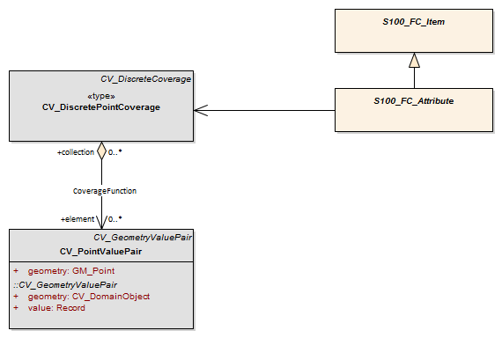
Figure 8-E-1 – Feature oriented discrete coverage
The model shown in Figure 8-E-2 below illustrates the collocation of two grids, supported by one grid value matrix to achieve the assignment of feature ID to specific cells. The discrete coverage allows for the assignment of feature codes to Grid Value Matrix entities and the continuous coverage allows one to handle the image.
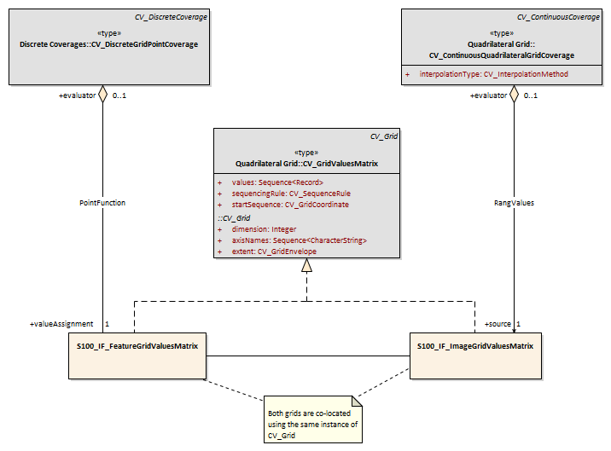
Figure 8-E-2 – Assigning feature codes to pixels in an image.
The second method of establishing a feature structure is to develop a composite dataset that contains many separate but adjoining coverages. The coverages may be continuous or discrete. This is very much like the way a "vector" dataset is composed where each feature has its own geometry and attributes. In fact vector data may be mixed with coverage data in the same dataset. The Application Schema simply allows multiple instances of features.
Geometric elements such as grids may be shared between multiple features, and features may be related by composition or other relationships as allowed in the general feature model of ISO 19109. A complex feature may include both a continuous grid coverage and vector data such as a polygonal boundary. A feature oriented dataset may contain both a continuous coverage of the ocean as collected by sonar, and point and line features corresponding to navigational aids. Topological primitives may relate all of the features. This allows for some interesting and useful structures. For example, a scanned paper map represented as a gridded dataset may include additional vector data describing the roads and other features on the scanned map, which is not "visible" in that it is not portrayed, but which is active in that a user might query the name of a feature or traverse along a road on what would appear to be a gridded data set.

There is a commonality between the text in portions of this standard and in the ISO standard 19129 because sections of this document have been contributed to ISO as input in the development of ISO 19129 and have thus been incorporated into the ISO document.
References to superseded ISO 191xx standards have been removed or updated.

